Appendix A: Brainstorm for Project Ideas

Image of original brainstorm 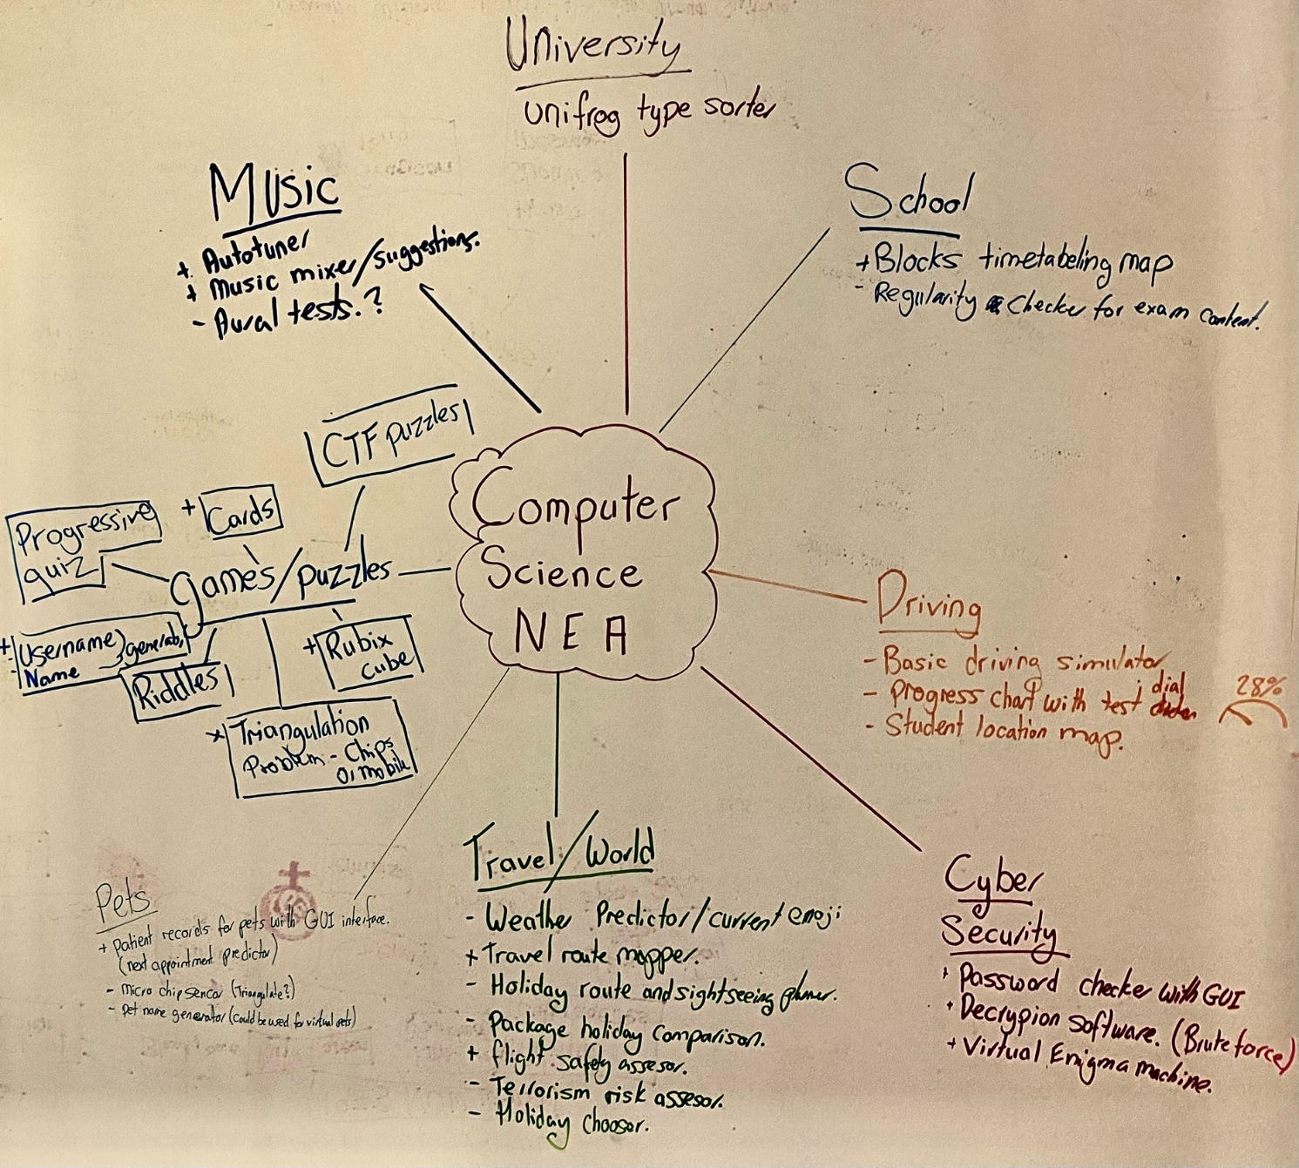

Appendix B: Stakeholder Research
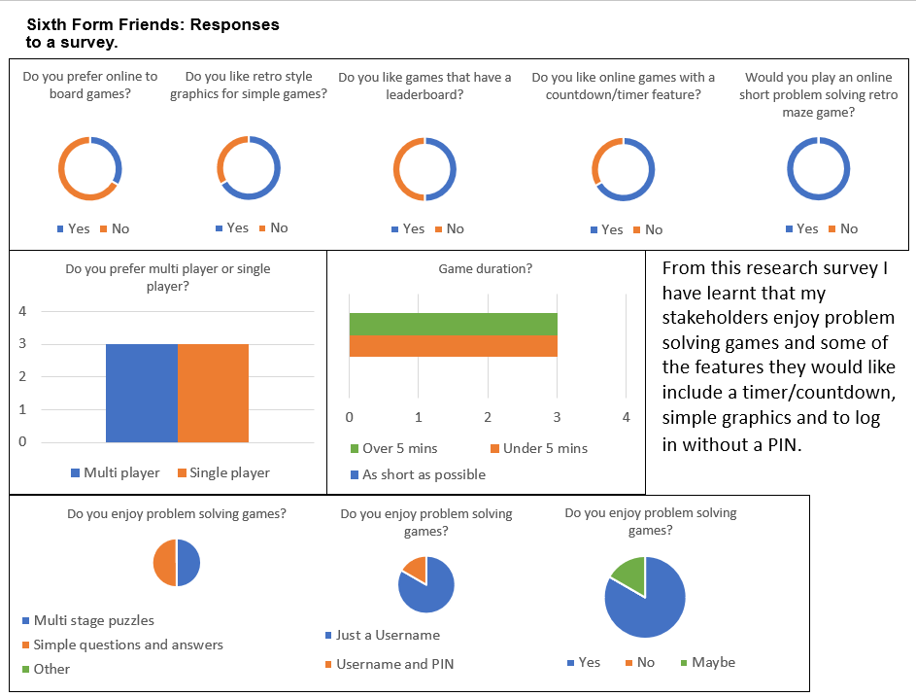

After some work on design of the game interface I sent out this survey for more stakeholder feedback from a wider range of stakeholders.
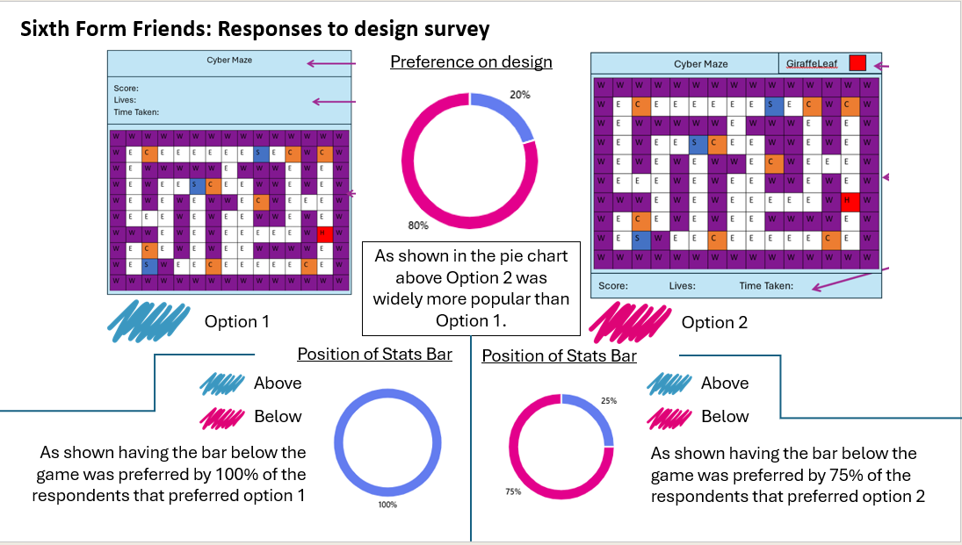

Notes from computer science teacher stakeholder meeting:
- He would like a resource that introduces pupils to cyber security in a fun way
- He would like something that might encourage people to try for CyberFirst girls
- He would like something that might encourage more pupils to take GCSE computing
- He would like a feature that allows him to check on progress
- He would like a feature like a leaderboard
- His advice was to have different levels of challenge - e.g. easy, medium, hard

Notes from Cyber Security Professional Stakeholder Meeting:
I talked to a cyber security professional today from the National Cyber Security Centre. These are the key things I noted down.
- NCSC created CyberFirst to encourage school pupils into a cyber security career.
- CyberFirst is aimed at students from all backgrounds.
- NCSC created the Year 8 CyberFirst Girls Competition to encourage female talent into cyber security.
- The aim of CyberFirst is to encourage applications for a CyberFirst bursary.
- My game proposal could be a good way of encouraging students to think cyber security is fun.
- My key aim is to make it fun so that people might be open to learning more about cyber security.

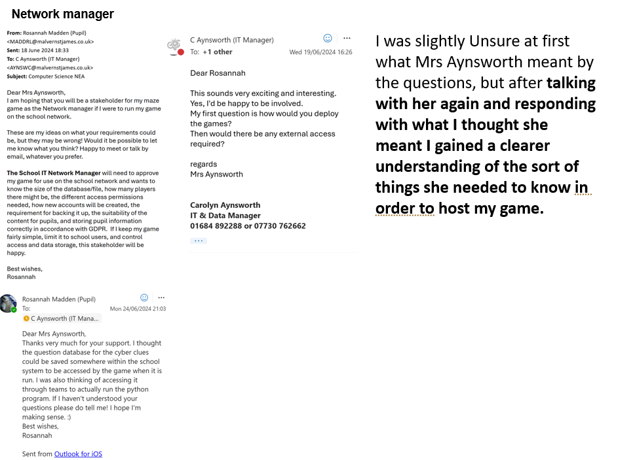

Appendix C: Source Code
Interfaces.py
#interfaces.py
#code to generate the cyber maze GUI's
#and link to button event callbacks,
#including acessing the database

#Rosa Madden
#25/10/2024

#line 126

#import python library modules
import tkinter as tk
#import tkinter.tkk as tkk #for widgets such as combo list boxes
from tkinter import ttk
import tkinter.messagebox as mbox #for messages
from tkinter import END # a special char used to denote the end of a text box string
from PIL import Image, ImageTk #for image manipulation

##import my own files
from callbacks01 import * #manage events

#global theme colours
global BackCol, TextCol, BtnCol
BackCol = "purple" #defalt bg color
TextCol = "white" #default font color
BtnCol = "DarkOrange2" #Button color

##event handlers

#log in
def Submit(): #Subprogram to check Username before entering the System
global root, Username
#event handler for btnSubmit
aStr = txtUsername.get() #get entered username
txtUsername.delete(0,END) #remove a Username after input.
if aStr != "Welcome please enter your username": #stop temp text being entered
if GetUser(aStr): #Authentication of username
#move guis
frmLogIn.place(x = 5, y = 500, width = 645, height = 207)
frmOptions.place(x = 0, y = 0, width = 645, height = 207)
width, height = 645, 207
root.geometry("{}x{}".format(width,height)) #reset root just in case
#method to destroy widgets
txtUsername.destroy() #remove txtUsername when leaving this frame
Username = aStr #save Username for later use (Admin) - query for Avatar.
if not UserAdmin(Username): #greying out Admin management in options
btnAdmin["bg"] = "DarkOrange3"
btnAdmin["fg"] = "grey80"
else:
btnAdmin["bg"] = BtnCol #standard
btnAdmin["fg"] = TextCol
else:
mbox.showerror("No Username Entered", "Error, This Username cannot be submitted") #error for temp text entered
##print(NumAttempts) #test print
return #end procedure

def Exit(): #procedure to quit
Cancel()
return #end procedure

def MoveMAccount(): #procedure for New User event
#Set global variables
global frmLogIn, frmManage, txtNUser, txtUsername, root, pressed

#place entry box in
#(may have been previously deleted for temp text reset)
txtNUser = tk.Entry(frmManage, text = "",
bg = TextCol,fg = "dim gray", borderwidth=2, font=('Bahnschrift', 11)) #settings
txtNUser.place(x = 143, y = 68, width = 478, height = 46) #position

#tempory text in Entry box
def Ntemp_text(e):
txtNUser["fg"] = "black"
txtNUser.delete(0,END)
return e
tempNreset()
txtNUser.bind("<FocusIn>", Ntemp_text)

#shuffle the frame placement
frmLogIn.place(x = 5, y = 500, width = 645, height = 207)
frmManage.place(x = 0, y = 0, width = 645, height = 207)
width, height = 645, 207
root.geometry("{}x{}".format(width,height))#reset the window size just in case
#remove input box in Login GUI for reset later
txtUsername.destroy()
pressed = 1 #set value for the avatar selection default

def tempNreset(): #procedure to reset temp text in Manage account
#procedure called whenever move to manage account GUI
global txtNUser
aStr = txtNUser.get()
if aStr != "Please enter a username": #check for preexisting temp text
txtNUser.insert(0, "Please enter a username") #if not already there enter temp text
return

#options
def LogIn(): #procedure for back to login
#Declare global variables
global txtUsername, root
action = mbox.askyesno("Account", "If you do this you will have to log in again, are you sure?") #Ensure the user is happy to exit this account
if action: #is true
Attempts = 0 #reset attempts
resetAttempts(Attempts)
#shuffle frames
frmLogIn.place(x = 0, y = 0, width = 645, height = 207)
frmOptions.place(x = 5, y = 500, width = 645, height = 207)
width, height = 645, 207
root.geometry("{}x{}".format(width,height)) #reset window size just in case

#Reset the username input box – reinput temp text
txtUsername = tk.Entry(frmLogIn, text = "",
bg = TextCol,fg = "dim gray", borderwidth=2, font=('Bahnschrift', 11)) #style
txtUsername.place(x = 143, y = 68, width = 478, height = 46) #position

def temp_text(e): #function to reset temp text in Username input
#change the text colour on click
txtUsername["fg"] = "black"
txtUsername.delete(0,END)
return e
tempreset() #call procedure below to reset username input box (set temp text)
txtUsername.bind("<FocusIn>", temp_text) #set event handler

return #end procedure

def tempreset(): #procedure to reset Username input box
global txtUsername #globally declare button
aStr = txtUsername.get()
if aStr != "Welcome please enter your username": #check if temp text already input
txtUsername.insert(0, "Welcome please enter your username") #enter temp text if not already there
return #end procedure

def ManageAcc(): #procedure for event handler Manage Account button
#Declare globals
global frmLogIn, frmManage, txtNUser, txtUsername, root, pressed
action = mbox.askyesno("Mannage Account", "If you do this you will have to log in again, are you sure?") #Ensure the user is happy to exit this account
if action: #if true
#reset Manage account username input box
txtNUser = tk.Entry(frmManage, text = "",
bg = TextCol,fg = "dim gray", borderwidth=2, font=('Bahnschrift', 11)) #style
txtNUser.place(x = 143, y = 68, width = 478, height = 46) #position

#tempory text in Entry box (event handling)
def Ntemp_text(e):
txtNUser["fg"] = "black"
txtNUser.delete(0,END)
return e
tempNreset() #reset input box
txtNUser.bind("<FocusIn>", Ntemp_text) #reset input box event handler

#move frames
frmOptions.place(x = 5, y = 500, width = 645, height = 207)
frmManage.place(x = 0, y = 0, width = 645, height = 207)
width, height = 645, 207
root.geometry("{}x{}".format(width,height)) #reset window size just in case
pressed = 1 #default pressed

return #end procedure

def ManageAdmin(): #Admin button event handler
if UserAdmin(Username): #function to check if current user is admin
#if true – move frames
frmOptions.place(x = 5, y = 500, width = 645, height = 207)
frmAdmin.place(x = 0, y = 0, width = 645, height = 207)
width, height = 645, 207
root.geometry("{}x{}".format(width,height)) #reset window size
#input file type to be entered
txtClue.insert(0, ".txt")
txtMaze.insert(0, ".txt")
else:
#if false – access denied
mbox.showerror("Permission Denied", "User '%s' is not permited here"%Username)

return #end procedure

def LeaderboardsO(): #Leaderboards button event handler
#set globally declare variables
global Leaderg
#move frames
frmOptions.place(x = 5, y = 500, width = 645, height = 207)
frmLeader.place(x = 0, y = 0, width = 645, height = 207)
width, height = 645, 207
root.geometry("{}x{}".format(width,height)) #reset window size just in case

#reload game selection options just in case
Leaderg = Games()
length = len(Leaderg)
#print(length) #test print
count = 0
Game = []
for count in range (0, length):
#add only game names to Game array
Game.append(Leaderg[count][0])
count = count+1
#sorts the list alphabetically
Game = sorted(Game)
clbGames.config(values=Game) #set drop down values
return #end procedure

def Play_Game(): #event handler for Play Game button in options
#Declare globals
global root, frmPlayGame, frmOptions, NickDiff, Game
#move frames
frmOptions.place(x = 5, y = 500, width = 645, height = 207)
frmPlayGame.place(x = 0, y = 0, width = 645, height = 207)
width, height = 645, 207
root.geometry("{}x{}".format(width,height)) #reset window size just in case

if UserAdmin(Username): #grey out Submit button for admin users
btnSubmitGame["bg"] = "DarkOrange3"
btnSubmitGame["fg"] = "grey80"
else:
btnSubmitGame["bg"] = BtnCol #standard style
btnSubmitGame["fg"] = TextCol

#reload game selection drop down just in case
NickDiff = Games()
length = len(NickDiff)
#print(length) #test print
count = 0
Game = []
for count in range (0, length):
#add game name only to Game array
Game.append(NickDiff[count][0])
count = count+1
#sorts list alphabetically
Game = sorted(Game)
clbGameSelect.config(values=Game) #sets array Game to drop down list

return #end procedure

#play game
def OptionsMove(): #event handler for back button within play game gui
#move frames
frmPlayGame.place(x = 5, y = 500, width = 645, height = 207)
frmOptions.place(x = 0, y = 0, width = 645, height = 207)
width, height = 645, 207
root.geometry("{}x{}".format(width,height)) #reset window just in case
clbGameSelect.set('Select a game...') #reset temp text in drop downs
clbGameDiff.set('Sort by Difficulty...')
return #end procedure

def PlaySelected(): #event handler for game submit
SelectedGame = clbGameSelect.get() #get game nickname for selected game
if SelectedGame == "Select a game...": #disallow entry of temp text
mbox.showerror("Invalid Input", "Error, A Game must be selected")
else:
if not UserAdmin(Username): #no warning message for users playing games
PlayMSelected(SelectedGame, Username)
else:
mbox.showinfo("Permission Denied", "Admin user '%s' cannot play games but can check if they load"%Username) #warning message that Admins can’t play games
PlayMSelected(SelectedGame, Username)
return #end procedure

def GameDiff(): #to sort the games by difficulty
selecteddiff = clbGameDiff.get() #change the values in drop down according to filter
Easy = []
Med = []
Hard = []
All = []
length = len(NickDiff)
for count in range (0, length):
#check difficulty of each game in array before saving only game name to specific arrays
if NickDiff[count][1] == 1: #if easy
Easy.append(NickDiff[count][0]) #add only game name
## print(Easy) #test print
elif NickDiff[count][1] == 2: #if medium
Med.append(NickDiff[count][0])
## print(Med) #test print
elif NickDiff[count][1] == 3: #if hard
Hard.append(NickDiff[count][0])
All.append(NickDiff[count][0]) #add all values

## print(Hard) #test print
if selecteddiff == "Easy": #sort arrays alphabetically
Easy = sorted(Easy)
clbGameSelect.config(values=Easy) #set the values in the drop down
elif selecteddiff == "Medium":
Med = sorted(Med)
clbGameSelect.config(values=Med)
elif selecteddiff == "Hard":
Hard = sorted(Hard)
clbGameSelect.config(values=Hard)
elif selecteddiff == "All": #if all are selected
All = sorted(All)
clbGameSelect.config(values=All)
return #end procedure

#manage account
def which_button(button_press): #change button graphics dependant on button pressed
#declare globals
global pressed

#for previous button
#maintain other button view
Imagereset = ("Avatar0%i.png"%pressed)
original_image = Image.open(Imagereset)
# Scale the image (change width and height as needed)
width, height = 45, 45 # Desired dimensions
scaled_image = original_image.resize((width, height), Image.LANCZOS)
# Convert the scaled image to a Tkinter-compatible image
tk_image = ImageTk.PhotoImage(scaled_image)
if pressed == 1: #declare the image for the correct previously selected avatar
imgAvatar1.config(image=tk_image) #set image
imgAvatar1.image = tk_image
elif pressed == 2:
imgAvatar2.config(image=tk_image) #set image
imgAvatar2.image = tk_image
elif pressed == 3:
imgAvatar3.config(image=tk_image) #set image
imgAvatar3.image = tk_image
elif pressed == 4:
imgAvatar4.config(image=tk_image) #set image
imgAvatar4.image = tk_image

#change view of selected button
imagedarker = ("Avatar%i-dark70.png"%button_press) #change the newly selected button to the selected appearance
original_image = Image.open(imagedarker)
# Scale the image (change width and height as needed)
width, height = 45, 45 # Desired dimensions
scaled_image = original_image.resize((width, height), Image.LANCZOS)
# Convert the scaled image to a Tkinter-compatible image
tk_image = ImageTk.PhotoImage(scaled_image) #set image

if button_press== 1: #set to a specific button
imgAvatar1.config(image=tk_image)
imgAvatar1.image = tk_image
pressed=1
## print(pressed) #test print
return 1 #return the currently selected
elif button_press == 2:
imgAvatar2.config(image=tk_image)
imgAvatar2.image = tk_image
pressed=2
## print(pressed) #test print
return 2 #return the currently selected
elif button_press == 3:
imgAvatar3.config(image=tk_image)
imgAvatar3.image = tk_image
pressed=3
##print(pressed) #test print
return 3 #return the currently selected
elif button_press == 4:
imgAvatar4.config(image=tk_image)
imgAvatar4.image = tk_image
pressed=4
## print(pressed) #test print
return 4 #return the currently selected

def Save(): #event handler for the save button within manage account
#event handler for btnSubmit
aStr = txtNUser.get() #get entered username
AvatarID = pressed #number 1-4 currently selected avatar
edit = False
## print(aStr[:2]) #test print
if UserPresence(aStr): #check if there is already a user
#allow for accidental input of currently existing account
edit = mbox.askyesno("Edit", "Are you sure you like to edit this account?")
#set edit for later if statment
#print(edit) #test print

else:
edit = True #edit is always true if new account

if edit:
action = False
if aStr[:2] == "A_": #admin type account
Type = "A"
if not UserPresence(aStr): #check if wishes to create an admin account
action = mbox.askyesno("Admin", "Are you sure you like this account to be an Admin?")
else:
action = True #action is always True if editing a preexisting account
else:
Type = "U"
action = True
if action: #allow for editing of database data
if aStr != "Please enter a username": #check for temp text
AvatarID = pressed
AddUser(aStr, AvatarID, Type) #data is edited within callbacks with passed parameters
else:
mbox.showerror("No Username Entered", "Error, This Username cannot be submitted") #error due to temp text entered
else:
mbox.showinfo("Admin not added", "User not added, please enter a Username without 'A_' at the start") #error
return #end prodedure

def LogInN(): #event handler for button “back to login” reset username input box
#declare globals
global txtUsername, txtNUser, root
Attempts = 0 #rest attempts
resetAttempts(Attempts)
#move frames
frmLogIn.place(x = 0, y = 0, width = 645, height = 207)
frmManage.place(x = 5, y = 500, width = 645, height = 207)
width, height = 645, 207
root.geometry("{}x{}".format(width,height)) #reset window just in case

txtUsername = tk.Entry(frmLogIn, text = "",
bg = TextCol,fg = "dim gray", borderwidth=2, font=('Bahnschrift', 11)) #input box style
txtUsername.place(x = 143, y = 68, width = 478, height = 46) #position

def temp_text(e):
#change text colour on click
txtUsername["fg"] = "black"
#delete text on click
txtUsername.delete(0,END)
return e
tempreset() #reset temp text
txtUsername.bind("<FocusIn>", temp_text) #reset event handler for Login GUI
txtNUser.destroy() #delete Username input in Manage account to be reset when needed

return #end procedure

#Admin Management
def OptionsA(): #event handler for back button in Admin management
#move frames
frmOptions.place(x = 0, y = 0, width = 645, height = 207)
frmAdmin.place(x = 5, y = 500, width = 645, height = 207)
width, height = 645, 207
root.geometry("{}x{}".format(width,height)) #reset window size if needed
txtNick.delete(0,END) #remove Display name text when re-entering GUI.
txtClue.delete(0,END) #remove Clue file text when re-entering GUI.
txtMaze.delete(0,END) #remove Maze file text when re-entering GUI.
clbDifficulty.set('Difficulty...') #reset clb temp text
clbMaxTime.set('Max Time...') #reset clb temp text
return #end procedure

def AddGame(): #event handler for save button in Admin management
Display = txtNick.get() #get nickname
Clue = txtClue.get() #get clueset filename
Maze = txtMaze.get() #get maze filename
Time = clbMaxTime.get() #get max time for game
Level = clbDifficulty.get() #get game difficulty level
if Display != '' and Maze != '.txt' and Clue != '.txt' and Maze != '' and Clue != '' and Time != 'Max Time...' and Level != 'Difficulty...': #don’t allow blank inputs
#check 4 characters at the end of a string are the file type
if Clue[-4:] == ".txt" and Maze[-4:] == ".txt":
ManGame(Display, Clue, Maze, Time, Level) #pass the parameters to this procedure to save the game data
else:
mbox.showerror("Incorrect filetype", "Error, Clue sets and Mazes must be in text files") #filetype error
else:
mbox.showerror("Invalid Input", "Error, Not all fields have been filled please try again") #error invalid input
return #end procedure

#Leaderboard
def ViewLeader(): #event handler for the submit button within the leaderboards GUI
NickName = clbGames.get() #get the selected game nickname
if NickName == "View specific game Leaderboard...": #check if temp text entered
mbox.showerror("Invalid Input", "Error, A Game must be selected") #error invalid input
else: #valid selection
if not UserAdmin(Username): #User Leaderboard
#call from function in callbacks
Top5 = Top5Out(NickName) #find the top 5 for specific game

#create main Leaderboard frame
global frmLeaderboard
frmLeaderboard = tk.Frame(root, bg = BackCol)
#move frames
frmLeaderboard.place(x = 0, y = 0, width = 645, height = 207)
frmLeader.place(x = 0, y = 500, width = 645, height = 207)

#Title Label
## print(NickName) #test print
Nickname = str(NickName)+ " Leaderboard" #Title
lblTitle = tk.Label(frmLeaderboard, text = (Nickname),
bg = BackCol,fg = TextCol,
anchor="w", font=('Bahnschrift', 16, 'bold')) #style
lblTitle.place(x = 25, y = 15, width = 250, height = 36) #position

#back Button
btnBack = tk.Button(frmLeaderboard, text = "Back",
bg = BtnCol ,fg = TextCol, font=('Bahnschrift', 11) )
btnBack.place(x = 561, y = 23, width = 57, height = 36)

#global frames for the top 5
global frmLeaderboard1, frmLeaderboard2, frmLeaderboard3, frmLeaderboard4, frmLeaderboard5
frmLeaderboard1 = tk.Frame(frmLeaderboard, bg = BackCol) #style
frmLeaderboard1.place(x = 0, y = 50, width = 560, height = 26) #position

frmLeaderboard2 = tk.Frame(frmLeaderboard, bg = BackCol)
frmLeaderboard2.place(x = 0, y = 79, width = 560, height = 26)

frmLeaderboard3 = tk.Frame(frmLeaderboard, bg = BackCol)
frmLeaderboard3.place(x = 0, y = 108, width = 560, height = 26)

frmLeaderboard4 = tk.Frame(frmLeaderboard, bg = BackCol)
frmLeaderboard4.place(x = 0, y = 137, width = 560, height = 26)

frmLeaderboard5 = tk.Frame(frmLeaderboard, bg = BackCol)
frmLeaderboard5.place(x = 0, y = 166, width = 560, height = 26)

#results
for count in range(0,5):
## print(Top5) #test print
## print(Top5[count]) #test print
#split values into different variables for each of the top 5
User, Score, Time, Acc = Top5[count]
#placeholders no longer needed due to the separated variables

First = ["User: '%s'" % User,"Score: '%s'" % Score,"Time Taken: '%s'" % Time,"Accuracy: '%s'" % Acc] #save all values with identical into text
Nums = ["1. ","2. ","3. ","4. ","5. "] #introduction numbering
if count == 0: #to change the frame meaning I can iterate through the count.
frame = (frmLeaderboard1) #set specific frame for each iteration
## print(frame) #test print
elif count == 1:
frame = (frmLeaderboard2)
elif count == 2:
frame = (frmLeaderboard3)
elif count == 3:
frame = (frmLeaderboard4)
elif count == 4:
frame = (frmLeaderboard5)

#number label for place in top 5
lbl = tk.Label(frame, text = (Nums[count]),
bg = BackCol,fg = TextCol,
anchor="w", font=('Bahnschrift', 11, 'bold')) #style
lbl.place(x = 11, y = 0, width = 50, height = 26) #position

#Username label
label1 = tk.Label(frame,text=First[0],
bg=BackCol,fg=TextCol,anchor="w",
font=('Bahnschrift', 11, 'bold')) #style
# Place the label
label1.place(x=61, y=0, width=150, height=26)

#Score label
label2 = tk.Label(frame,text=First[1],
bg=BackCol,fg=TextCol,anchor="w",
font=('Bahnschrift', 11, 'bold')) #style
# Place the label
label2.place(x=200, y=0, width=150, height=26)

#Time Label
label3 = tk.Label(frame,text=First[2],
bg=BackCol,fg=TextCol,anchor="w",
font=('Bahnschrift', 11, 'bold')) #style
# Place the label
label3.place(x=295, y=0, width=150, height=26) #300 works

#Accuracy label
label4 = tk.Label(frame,text=First[3],
bg=BackCol,fg=TextCol,anchor="w",
font=('Bahnschrift', 11, 'bold')) #style
# Place the label
label4.place(x=450, y=0, width=110, height=26)
count = count+1

#all labels in each column are in line.
#each iteration so this in the next frame down

#Event Handlers
btnBack['command'] = Temp_Back #back button

clbGames.set('View specific game Leaderboard...') #reset clb temp text
return #end procedure
else: #if Admin user

def UserMazeDeets(): #get the details of a selected user
UserGame = clbUsers.get() #get the user selected
for count in range(0, (len(UserDetails))): #get all the values for the user selected
if UserGame in UserDetails[count][0]:
User, Score, Time, Accuracy, Easy, Medium, Hard, Complete = UserDetails[count]
#### print(UserDetails[count] , ":)") #test print
## print(User, NickName, User, Score, Time, Accuracy) #test print
#message box to display result
mbox.showinfo("'%s' Maze"%(NickName), '''User: '%s'\nScore: '%i'\nTime: '%s'\nAccuracy: '%s'\nAmount Easy:%i\nAmount Medium: %i\nAmount Hard: %i\n"%s"'''%(User, Score, Time, Accuracy, Easy, Medium, Hard, Complete))
#message box to display results
return #end procedure

UserDetails = LeaderA(NickName) #get the details of all users for the game

#frame for new gui
#global frmLeaderboard
frmLeaderboard = tk.Frame(root, bg = BackCol)
#move frames
frmLeaderboard.place(x = 0, y = 0, width = 645, height = 207)
frmLeader.place(x = 0, y = 500, width = 645, height = 207)

#Title Label
global gameselected
gameselected = NickName
Nickname = NickName[:len(NickName)]
## print(Nickname) #test print
Nickname = str(Nickname)+ " Leaderboard" #create title for GUI
lblTitle = tk.Label(frmLeaderboard, text = (Nickname),
bg = BackCol,fg = TextCol,
anchor="w", font=('Bahnschrift', 16, 'bold')) #style
lblTitle.place(x = 25, y = 15, width = 400, height = 36) #position

#back Button
btnBack = tk.Button(frmLeaderboard, text = "Back",
bg = BtnCol ,fg = TextCol, font=('Bahnschrift', 11) ) #style
btnBack.place(x = 561, y = 23, width = 57, height = 36) #position

UserD = [] #array to fill with usernames
for count in range(0, (len(UserDetails))):
UserD.append(UserDetails[count][0]) #add only the Username

#drop down for all users
clbUsers = ttk.Combobox(frmLeaderboard, values = UserD,
text = "user details", state= "readonly",
font=('Bahnschrift', 16, 'bold')) #style
clbUsers.set('View Details from Users last Game ...') #temp text
clbUsers.place(x = 23, y = 65, width = 595, height = 38) #position

#view button
btnView = tk.Button(frmLeaderboard, text = "View",
bg = BtnCol ,fg = TextCol,
font=('Bahnschrift', 11) ) #style
btnView.place(x = 464, y = 109, width = 154, height = 38) #position

#Event Handlers
btnBack['command'] = Temp_Back #back button
btnView['command'] = UserMazeDeets #message box for selected user details

clbGames.set('View specific game Leaderboard...') #reset clb temp text
return #end procedure

def OptLeader(): #Leaderboards GUI to Options via back button
#move frames
frmOptions.place(x = 0, y = 0, width = 645, height = 207)
frmLeader.place(x = 5, y = 500, width = 645, height = 207)
width, height = 645, 207
root.geometry("{}x{}".format(width,height)) #rest window if needed
return #end procedure

def Temp_Back(): #back button event handler within embedded GUI
frmLeaderboard.destroy() #delete the leaderboard so that it can be updated not overwritten
frmLeader.place(x = 0, y = 0, width = 645, height = 207) #move leaderboard to window position
width, height = 645, 207
root.geometry("{}x{}".format(width,height)) #reset window size just in case.

##procedures to create GUI's
def Main():
Initialise() #call procedure to create window and set values
CreateLogIn() #create first GUI - Log In
Options() #Options GUI
play_Game() #game select GUI
ManageAccount() #Manage Account GUI
Admin() #Admin Management GUI
Leader() #Leaderboards GUI

#make sure Avatars are correct in database.
#call function from callbacks
CheckAvatar()

root.mainloop() #continualy manage GUIs until quit
return

def center_window(window):
#ref53: https://www.geeksforgeeks.org/how-to-center-a-window-on-the-screen-in-tkinter/
window.update_idletasks()
width = window.winfo_width() #identify window width
height = window.winfo_height() #identify window height
screen_width = window.winfo_screenwidth() #identify full screen width
screen_height = window.winfo_screenheight() #identify full screen height
x = (screen_width - width) // 2 #identify X of the top left corner using maths
y = (screen_height - height) // 2 #identify Y of the top left corner using maths
window.geometry(f"{width}x{height}+{x}+{y}") #set window location and size
return

def Initialise():
#Procedure to create window container for all GUIs
#declare Globals
global root #standard name for window

root = tk.Tk()#call library function

root.title("Cyber Maze Quiz") #Title for window

width, height = 645, 207
root.geometry("{}x{}".format(width,height))
#root.geometry("{}x{}+{}+{}".format(width,height, 0, 0)) # in the centre of the screen
center_window(root)
#root.eval('tk::PlaceWindow . center')

return #end procedure

def CreateLogIn(): #procedure to create the Log in GUI
#declare globals
global frmLogIn, txtUsername

#create the frame - container
#ref34:https://cs111.wellesley.edu/archive/cs111_fall14/public_html/labs/lab12/tkintercolor.html
#Tkinter named colours
frmLogIn = tk.Frame(root, bg = BackCol) #style
frmLogIn.place(x = 0, y = 0, width = 645, height = 207) #position

#add widgets
#ref35:https://www.geeksforgeeks.org/what-are-widgets-in-tkinter/
#types of widget
#GUI Title
lblLogIn = tk.Label(frmLogIn, text = "Log In",
bg = BackCol,fg = TextCol,
anchor="w", font=('Bahnschrift', 16, 'bold')) #style
lblLogIn.place(x = 25, y = 15, width = 201, height = 36) #position

#input indentifier
lblUsername = tk.Label(frmLogIn, text = "Username:",
bg = BackCol,fg = TextCol, anchor="w",
font=('Bahnschrift', 16)) #style
lblUsername.place(x = 11, y = 70, width = 124, height = 36) #position

#text input box
txtUsername = tk.Entry(frmLogIn, text = "",
bg = TextCol,fg = "dim gray",
borderwidth=2, font=('Bahnschrift', 11)) #style
txtUsername.place(x = 143, y = 68, width = 478, height = 46) #position

tempreset() #set up the temp text

#New user button
btnNewUser = tk.Button(frmLogIn, text = "New User",
bg = BtnCol ,fg = TextCol,
font=('Bahnschrift', 11) ) #style
btnNewUser.place(x = 143, y = 147, width = 130, height = 38) #position

#Submit button
btnSubmit = tk.Button(frmLogIn, text = "Log in",
bg = BtnCol ,fg = TextCol,
font=('Bahnschrift', 11) ) #style
btnSubmit.place(x = 290, y = 147, width = 130, height = 38) #position

#Cancel button
btnCancel = tk.Button(frmLogIn, text = "Cancel",
bg = BtnCol ,fg = TextCol,
font=('Bahnschrift', 11) ) #style
btnCancel.place(x = 491 , y = 147, width = 130, height = 38) #position

#set event handler

#tempory text in Entry box
#ref38:https://www.tutorialspoint.com/how-to-insert-a-temporary-text-in-a-tkinter-entry-widget

def temp_text(e):
#change the colour on click
txtUsername["fg"] = "black"
#delete contents on click
txtUsername.delete(0,END)
return e #end function
txtUsername.bind("<FocusIn>", temp_text)

btnSubmit['command'] = Submit #connect procedure to button click
btnCancel['command'] = Exit
btnNewUser['command'] = MoveMAccount

return #end procedure

def Options():
#options GUI
#Declare globals
global frmOptions, btnAdmin
#create the frame - container
#same size as Log on frame
frmOptions = tk.Frame(root, bg = BackCol) #style
frmOptions.place(x = 5, y = 217, width = 645, height = 207) #position

#same position as the Log In Title
#Option Title
lblOptions = tk.Label(frmOptions, text = "Options",
bg = BackCol,fg = TextCol,
anchor="w", font=('Bahnschrift', 16, 'bold')) #style
lblOptions.place(x = 25, y = 15, width = 201, height = 36) #position

#input identifier
btnManageAccount = tk.Button(frmOptions, text = "Manage Account",
bg = BtnCol ,fg = TextCol,
font=('Bahnschrift', 11) ) #style
btnManageAccount.place(x = 25, y = 63, width = 285, height = 38) #position

#button for Login GUI
btnLogIn = tk.Button(frmOptions, text = "Back",
bg = BtnCol ,fg = TextCol,
font=('Bahnschrift', 11) ) #style
btnLogIn.place(x = 333, y = 63, width = 285, height = 38) #position

#button for Play Game GUI
btnPlayGame = tk.Button(frmOptions, text = "Play Game",
bg = BtnCol ,fg = TextCol,
font=('Bahnschrift', 11) ) #style
btnPlayGame.place(x = 25, y = 107, width = 285, height = 38) #position

#button for Admin GUI
btnAdmin = tk.Button(frmOptions, text = "Admin Management",
bg = BtnCol ,fg = TextCol,
font=('Bahnschrift', 11) ) #style
btnAdmin.place(x = 25, y = 151, width = 593, height = 38) #position

#button for Leaderboards GUI
btnLeaderboards = tk.Button(frmOptions, text = "Leaderboards",
bg = BtnCol ,fg = TextCol,
font=('Bahnschrift', 11) ) #style
btnLeaderboards.place(x = 333, y = 107, width = 285, height = 38) #position

#set event handler – procedures connection to buttons
btnLogIn['command'] = LogIn
btnManageAccount['command'] = ManageAcc
btnPlayGame['command'] = Play_Game
btnAdmin['command'] = ManageAdmin
btnLeaderboards['command'] = LeaderboardsO
return #end procedure

def play_Game():
#Play Game GUI
#Declare Globals
global frmPlayGame, clbGameSelect, clbGameDiff, btnSubmitGame

#create the frame - container
#same size as Log on frame
frmPlayGame = tk.Frame(root, bg = BackCol) #style
frmPlayGame.place(x = 5, y = 429, width = 645, height = 207) #position

#same position as previous Title
#Play Game Title
lblPlayGame = tk.Label(frmPlayGame, text = "Play Game",
bg = BackCol,fg = TextCol,
anchor="w", font=('Bahnschrift', 16, 'bold')) #style
lblPlayGame.place(x = 25, y = 15, width = 201, height = 36) #position

#sort Button
btnSort = tk.Button(frmPlayGame, text = "Sort",
bg = BtnCol ,fg = TextCol,
font=('Bahnschrift', 11) ) #style
btnSort.place(x = 199, y = 115, width = 57, height = 36) #position

#back button
btnOptions = tk.Button(frmPlayGame, text = "Back",
bg = BtnCol ,fg = TextCol,
font=('Bahnschrift', 11) ) #style
btnOptions.place(x = 561, y = 23, width = 57, height = 36) #position

#enter button
btnSubmitGame = tk.Button(frmPlayGame, text = "Submit",
bg = BtnCol ,fg = TextCol,
font=('Bahnschrift', 11) ) #style
btnSubmitGame.place(x = 464, y = 109, width = 154, height = 38) #position

#combo list box – I have set some temporary values to be updated later
tempvalues = ["These", "are", "temporary", "values"] #values to be updated when GUI is accessed
clbGameSelect = ttk.Combobox(frmPlayGame, values = tempvalues,
text = "Select a game", state= "readonly",
font=('Bahnschrift', 16, 'bold')) #style
clbGameSelect.set('Select a game...') #default text
clbGameSelect.place(x = 23, y = 65, width = 595, height = 38) #position

#Game Difficulty drop down
Level = ["Easy", "Medium", "Hard", "All"] #options
clbGameDiff = ttk.Combobox(frmPlayGame, values = Level,
text = "Select Game Difficulty", state= "readonly",
font=('Bahnschrift', 13)) #style
clbGameDiff.set('Sort by Difficulty...') #default text
clbGameDiff.place(x = 23, y = 115, width = 170, height = 36) #position

#event handlers – connect buttons to procedures
btnSort['command'] = GameDiff
btnOptions['command'] = OptionsMove
btnSubmitGame['command'] = PlaySelected

return #end procedure

def ManageAccount():
#Manage account GUI
#declare globals
global frmManage, txtNUser, imgAvatar1, imgAvatar2, imgAvatar3, imgAvatar4

#create the frame - container
frmManage = tk.Frame(root, bg = BackCol) #style
frmManage.place(x = 655, y = 5, width = 645, height = 207) #position

#same position as previous Title
#Manage Account Title
lblManage = tk.Label(frmManage, text = "Manage Account",
bg = BackCol,fg = TextCol,
anchor="w", font=('Bahnschrift', 16, 'bold')) #style
lblManage.place(x = 25, y = 15, width = 201, height = 36) #position

#Identifier for the Entry box (same position as Login)
lblUsername = tk.Label(frmManage, text = "Username:",
bg = BackCol,fg = TextCol,
anchor="e", font=('Bahnschrift', 16)) #style
lblUsername.place(x = 11, y = 70, width = 122, height = 36) #position

#Usernsme entry box (same position as Login)
txtNUser = tk.Entry(frmManage, text = "",
bg = TextCol,fg = "dim gray", borderwidth=2,
font=('Bahnschrift', 11)) #style
txtNUser.place(x = 143, y = 68, width = 478, height = 46) #position

#temporary text for input
txtNUser.insert(0, "Please enter a username")

#back button (for returning to login)
btnLogIn = tk.Button(frmManage, text = "Return to Login",
bg = BtnCol ,fg = TextCol,
font=('Bahnschrift', 11) ) #style
btnLogIn.place(x = 464, y = 15, width = 154, height = 38) #position

#Identifier for the Avatar buttons
lblAvatar = tk.Label(frmManage, text = "Avatar:",
bg = BackCol,fg = TextCol, anchor="e",
font=('Bahnschrift', 16)) #style
lblAvatar.place(x = 40, y = 150, width = 89, height = 36) #position

#button to save details from manage account
btnSave = tk.Button(frmManage, text = "Save",
bg = BtnCol ,fg = TextCol,
font=('Bahnschrift', 11) ) #style
btnSave.place(x = 464, y = 150, width = 154, height = 38) #position

#1
# Load the image using PIL
original_image = Image.open("Avatar1-dark70.png") #pre selected(darker image necessary)

# Scale the image
width, height = 45, 45 # Desired dimensions (square)
scaled_image = original_image.resize((width, height), Image.LANCZOS)

# Convert the scaled image to a Tkinter-compatible image
tk_image = ImageTk.PhotoImage(scaled_image)

# Create a button and set the image
imgAvatar1 = tk.Button(frmManage, image=tk_image, anchor="center",
command=lambda imgAvatar1 = 1: which_button(imgAvatar1)) #style
imgAvatar1.place(x = 142, y = 138, width = 47, height = 47) #position

# Keep a reference to avoid garbage collection
imgAvatar1.image = tk_image

#2
#Load the image using PIL
original_image2 = Image.open("Avatar02.png") #ordinary image (with background)

# Scale the image
width, height = 45, 45 # Desired dimensions (square)
scaled_image2 = original_image2.resize((width, height), Image.LANCZOS)

# Convert the scaled image to a Tkinter-compatible image
tk_image2 = ImageTk.PhotoImage(scaled_image2)

# Create a button and set the image
imgAvatar2 = tk.Button(frmManage, image=tk_image2, anchor="center",
command=lambda imgAvatar2 = 2: which_button(imgAvatar2)) #style
imgAvatar2.place(x = 205, y = 138, width = 47, height = 47) #position

# Keep a reference to avoid garbage collection
imgAvatar2.image = tk_image2

#3
#Load the image using PIL
original_image3 = Image.open("Avatar03.png") #ordinary image (with background)

# Scale the image
width, height = 45, 45 # Desired dimensions (square)
scaled_image3 = original_image3.resize((width, height), Image.LANCZOS)

# Convert the scaled image to a Tkinter-compatible image
tk_image3 = ImageTk.PhotoImage(scaled_image3)

# Create a button and set the image
imgAvatar3 = tk.Button(frmManage, image=tk_image3, anchor="center",
command=lambda imgAvatar3=3: which_button(imgAvatar3)) #style
imgAvatar3.place(x = 264, y = 138, width = 47, height = 47) #position

# Keep a reference to avoid garbage collection
imgAvatar3.image = tk_image3

#4
#Load the image using PIL
original_image4 = Image.open("Avatar04.png") #ordinary image (with background)

# Scale the image
width, height = 45, 45 # Desired dimensions (square)
scaled_image4 = original_image4.resize((width, height), Image.LANCZOS)

# Convert the scaled image to a Tkinter-compatible image
tk_image4 = ImageTk.PhotoImage(scaled_image4)

# Create a button and set the image
imgAvatar4 = tk.Button(frmManage, image=tk_image4, anchor="center",
command=lambda imgAvatar4 = 4: which_button(imgAvatar4)) #style
imgAvatar4.place(x = 325, y = 138, width = 47, height = 47) #position

# Keep a reference to avoid garbage collection
imgAvatar4.image = tk_image4

#tempory text in Entry box
#ref38:https://www.tutorialspoint.com/how-to-insert-a-temporary-text-in-a-tkinter-entry-widget
def Ntemp_text(e):
#change the colour on click
txtNUser["fg"] = "black"
#delete chars on click
txtNUser.delete(0,END)
return e
txtNUser.bind("<FocusIn>", Ntemp_text) #set click event

#Event Handlers
#send button value to function as a parameter
imgAvatar1['command'] = lambda imgAvatar1 = 1: which_button(imgAvatar1)
imgAvatar2['command'] = lambda imgAvatar2 = 2: which_button(imgAvatar2)
imgAvatar3['command'] = lambda imgAvatar3 = 3: which_button(imgAvatar3)
imgAvatar4['command'] = lambda imgAvatar4 = 4: which_button(imgAvatar4)
btnSave['command'] = Save
btnLogIn['command'] = LogInN
return #end procedure

def Admin():
#Admin Management GUI
#declare globals
global frmAdmin, txtNick, txtMaze, txtClue, clbMaxTime, clbDifficulty, clbLevel

#create the frame – same style as previous
frmAdmin = tk.Frame(root, bg = BackCol) #style
frmAdmin.place(x = 655, y = 220, width = 645, height = 207) #position

#title for GUI (same position as above)
lblAdmin = tk.Label(frmAdmin, text = "Admin Management",
bg = BackCol,fg = TextCol,
anchor="w", font=('Bahnschrift', 16, 'bold')) #style
lblAdmin.place(x = 25, y = 15, width = 201, height = 36) #position

#identifier for maze nickname input box
lblNick = tk.Label(frmAdmin, text = "Display Name:",
bg = BackCol,fg = TextCol,
anchor="e", font=('Bahnschrift', 12)) #style
lblNick.place(x = 24, y = 63, width = 136, height = 31) #location

#input box for maze nickname
txtNick = tk.Entry(frmAdmin, text = "",
bg = TextCol,fg = "black", borderwidth=2,
font=('Bahnschrift', 12)) #style
txtNick.place(x = 170, y = 67, width = 300, height = 28) #position

#identifier for clueset file input box
lblClue = tk.Label(frmAdmin, text = "Clue Set filename:",
bg = BackCol,fg = TextCol,
anchor="e", font=('Bahnschrift', 12)) #style
lblClue.place(x = 24, y = 102, width = 136, height = 31) #position

#input box for Clue set filename
txtClue = tk.Entry(frmAdmin, text = "",
bg = TextCol,fg = "black", borderwidth=2,
font=('Bahnschrift', 12)) #style
txtClue.place(x = 170, y = 105, width = 300, height = 28) #position

#identifier for Maze filename input box
lblMaze = tk.Label(frmAdmin, text = "Maze filename:",
bg = BackCol,fg = TextCol,
anchor="e", font=('Bahnschrift', 12)) #style
lblMaze.place(x = 24, y = 139, width = 136, height = 31) #position

#input box for Maze filename
txtMaze = tk.Entry(frmAdmin, text = "",
bg = TextCol,fg = "black", borderwidth=2,
font=('Bahnschrift', 12)) #style
txtMaze.place(x = 170, y = 143, width = 300, height = 28) #position

#button to save Maze details to database
btnSave = tk.Button(frmAdmin, text = "Save",
bg = BtnCol ,fg = TextCol, font=('Bahnschrift', 11) ) #style
btnSave.place(x = 483, y = 143, width = 135, height = 28) #position

#max time drop down
clbTimeValues = ["00:02:00"], ["00:05:00"], ["00:10:00"], ["00:15:00"], ["00:20:00"], ["00:25:00"], ["00:30:00"] #max time options
clbMaxTime = ttk.Combobox(frmAdmin, values = clbTimeValues, state= "readonly",
font=('Bahnschrift', 11, 'bold')) #style
clbMaxTime.set('Max Time...') #tempory text in drop down
clbMaxTime.place(x = 483, y = 67, width = 135, height = 28) #position

#Level selection drop down
clbLevel = ["Easy"],["Medium"],["Hard"] #difficulty level options
clbDifficulty = ttk.Combobox(frmAdmin, values = clbLevel, state= "readonly",
font=('Bahnschrift', 11, 'bold')) #style
clbDifficulty.set('Difficulty...') #temporary text in drop down
clbDifficulty.place(x = 483, y = 105, width = 135, height = 28) #position

#back button (same style as previous GUIs)
btnOptions = tk.Button(frmAdmin, text = "Back",
bg = BtnCol ,fg = TextCol,
font=('Bahnschrift', 11) ) #style
btnOptions.place(x = 561, y = 23, width = 57, height = 36) #position

#Event Handlers – 2 buttons
btnOptions['command']= OptionsA
btnSave['command']= AddGame

return #end procedure

def Leader():
#Leaderboard selection GUI
#declare globals
global frmLeader, Leaderg, clbGames

#frame – container for widgets (same size and style as previous
frmLeader = tk.Frame(root, bg = BackCol) #style
frmLeader.place(x = 655, y = 429, width = 645, height = 207) #position

#Leaderboards GUI Title
#same position as previous titles
lblLeader = tk.Label(frmLeader, text = "Leaderboards",
bg = BackCol,fg = TextCol,
anchor="w", font=('Bahnschrift', 16, 'bold')) #style
lblLeader.place(x = 25, y = 15, width = 201, height = 36) #position

#submit button to view a specific game leaderboard
btnView = tk.Button(frmLeader, text = "View",
bg = BtnCol ,fg = TextCol, font=('Bahnschrift', 11) ) #style
btnView.place(x = 464, y = 109, width = 154, height = 38) #position

#back button to navigate to options GUI
btnBack = tk.Button(frmLeader, text = "Back",
bg = BtnCol ,fg = TextCol, font=('Bahnschrift', 11) ) #style
btnBack.place(x = 561, y = 23, width = 57, height = 36) #position

#selection box for game leaderboard
Leaderg=["Temporary"],["Leaderboard"], ["Values"] #to allow for updating whenever the GUI is accessed
clbGames = ttk.Combobox(frmLeader, values = Leaderg,
text = "View specific game leaderboards", state= "readonly",
font=('Bahnschrift', 16, 'bold')) #style
clbGames.set('View specific game Leaderboard...') #drop down temporary text
clbGames.place(x = 23, y = 65, width = 595, height = 38) #position

#event handlers – 2 buttons
btnView['command'] = ViewLeader
btnBack['command'] = OptLeader
return #end procedure

##Main
Main() #call main to load in GUIs

Callbacks01.py
#callbacks01.py
#library of subprograms to support the GUIs
#Rosa Madden 02/11/24

import tkinter.messagebox as mbox #for messages
from PlayGame01 import * #access game play code library
from LogOnDataBase import * #access the database code library

#Log in
def GetUser(aStr):
#function to validate and authenticate a username
#print(aStr + ":", end = '')
C_MaxAttempts = 3 #const - max number og attampts allowed
global NumAttempts #allows for modification of NumAttempts
AuthLogIn = False #default

if IsValid(aStr) and IsAuth(aStr): #to check if aStr (username) is valid and authentic
## print("True") #test print
AuthLogIn=True #enter if statement below
else: #failed validation or authentication
## print("False") #test print
NumAttempts = NumAttempts + 1 #imcrement global NumAttempts count
## print("%i Login Attempt(s)" %NumAttempts) #test print

#skip unless authorised input
if AuthLogIn: #sucessful attempt
#get users details
aQry = '''SELECT * FROM User
WHERE UserName = "%s"''' %aStr #query to find user details as a double check
AnsTable = RunQuery(DBFile,aQry) #is auth proved they are there
## print(AnsTable) #test print
#print("Welcome '%s'" %AnsTable[0][1])
mbox.showinfo("Log In Sucess", "Welcome '%s'" %AnsTable[0][1]) #use Username from
return True #end function return true

elif NumAttempts == C_MaxAttempts: #failed log in after max goes
## print("Log In failed after %i goes" %NumAttempts) #test print
mbox.showerror("FAILED", "Log In failed after %i attempts" %NumAttempts) #message box for 3 failed attempts
quit() #quit the game
return False #end function return false

def Cancel(): #to quit the game
action = mbox.askyesno("Cancel", "Are you sure?, This will close down this application") #verification required
if action: #ask before shutting down
quit() #quit the game
return #end procedure

def resetAttempts(Attempts): #attempt manager
global NumAttempts
NumAttempts = Attempts #reset attempts for re-entry into portal
return #end procedure

#manage account centered sub programs
def AddUser(aStr, AvatarID, Type):
#function to validate and authenticate a username
## print(aStr + ":", end = '') #test print
Valid = False #default

if IsValid(aStr): #validate input username
## print("Username is valid") #test print
Valid = True #valid if the Username is
## else:
## print("not valid") #test print
if Valid:
if NotAuth(aStr): #check if the username is authentic
#if new user:
aDML = '''INSERT INTO User(UserName,Type, AvatarID) VALUES("%s", "%s", %i)''' % (aStr, Type, AvatarID) #using SQL to add a record to the User table
AddData(DBFile, aDML)
aQry = '''SELECT * FROM User
WHERE UserName = "%s"''' %aStr #double check
AnsTable = RunQuery(DBFile,aQry) #is auth proved they are there
## print(AnsTable) #test print
if AnsTable[0][2] == "U": #get the user type for message box
Type = "User"
else:
Type = "Admin"
mbox.showinfo("Account Created", "Welcome '%s' '%s'" %(Type, AnsTable[0][1])) #personalised User added pop up message
else:
#editing a current user:
#get users details
aQry = '''SELECT * FROM User
WHERE UserName = "%s"''' %aStr
AnsTable = RunQuery(DBFile,aQry) #is auth proved they are there
#print(AnsTable) #Test print (double check record is there)
aDML = ('''UPDATE User SET AvatarID=%i WHERE UserName="%s"'''%(AvatarID, aStr)) #DML update to edit the current user input
AddData(DBFile, aDML) #execute DML
#get users details to test
aQry = '''SELECT * FROM User
WHERE UserName = "%s"''' %aStr
AnsTable = RunQuery(DBFile,aQry)
## print(AnsTable) #test print
if AnsTable[0][2] == "U": #get the user type for message box
Type = "User"
else:
Type = "Admin"

mbox.showinfo("Account Edited", "'%s' '%s' has been successfully edited" % (Type, AnsTable[0][1]) #personalised User edited pop up message
return #end proceure

def NotAuth(aStr):
#function to query the User table in the database to a match to a valid aStr
#without error pop ups (to use in the Manage account GUI)

#create query – to find User record (or not)
Qry = '''SELECT UserName FROM User
WHERE UserName = "%s"''' %aStr
#run query - DBFile set global in LogOnDatabase for Database file
AnsTable = RunQuery(DBFile, Qry)

#test result - Usernames are unique
if AnsTable: #found match
return False #end function return False
else:
return True #end function return True

def IsAuth(aStr):
#function to query the User table in the database to a match to a valid aStr
#with error messages (to use in the Login GUI)

#create query – to find User record (or not)
Qry = '''SELECT UserName FROM User
WHERE UserName = "%s"''' %aStr
#run query - DBFile set global in LogOnDatabase for Database file
AnsTable = RunQuery(DBFile, Qry)

#test result - Usernames are unique
if AnsTable: #found match
return True #end function return True (username found)
else:
mbox.showerror("Authentification Failed", "Error Authentification failed, '%s' is not a valid Username"%aStr) #error message for non existing username
return False #end function return false (username not found)

def IsValid(aStr):
#function to perform a validation checks on aStr
#Return True if all passed false otherwise
#used for both Login and Manage Account
ValidChars = "abcdefghijklmnopqrstuvwxyz0123456789_" #string = array of chars available

#use imbedded if statements for each check with return True at the inner most if
if aStr != "": #passes validation check - NULL

if len(aStr) >=1 and len(aStr) <= 12: #passes length check – 1-12 inclusive

#conditional linear search to check char by char
IsGood = True #boolean loop control valid
CharNum = 0 #index into a Str

while IsGood and CharNum < len(aStr): #to check for invalid characters
aChar = aStr[CharNum] #get a char to check – loop through all for while

if aChar.lower() in ValidChars: #good char
CharNum = CharNum + 1 #get next char
else:
IsGood = False #quit checking
#why did loop quit?
if IsGood:
return True #aStr passes all validation checks – return True
else:
mbox.showerror("Validation Failed", "Error Validation failed, Username: '%s' contains forbidden characters"%aStr) #custom error message for specific validation error
return False #aStr failed type check – invalid char(s)

else: #fails length check
mbox.showerror("Validation Failed", "Error Validation failed, Username: '%s' is too long"%aStr) #custom error message for specific validation error
return False #aStr failed length check – too long >12
else: #fails presence check
mbox.showerror("Validation Failed", "Error Validation failed, No Username entered") #custom error message for specific validation error
return False #aStr failed presence check - NULL

#play game – drop down
def Games():
#create query – to find the Nickname and difficulty for all available games.
Qry = '''SELECT NickName,Difficulty FROM Maze'''
#run query - DBFile set global in LogOnDatabase for Database File
AnsTable = RunQuery(DBFile, Qry)
## print(AnsTable) #test print
return AnsTable #end function return List found in Query

#Admin Management
def ManGame(NickName, CFilename, MFilename, MaxTime, Difficulty):
#function to validate and authenticate a username
## print(NickName + ":", end = '')
## print(CFilename + ":", end = '')
## print(MFilename + ":", end = '')
Valid = False #default value for Valid

if Difficulty == "Hard": #to get difficulty into the correct format
Difficulty = 3
elif Difficulty == "Medium":
Difficulty = 2
else:
Difficulty = 1

#to stop SQL injection – check for Valid inputs for all input boxes
if ValidInp(CFilename):
## print("Clueset is valid") #test print
if ValidInp(MFilename):
## print("MFilename is valid") #test print
if ValidInp(NickName):
## print("NickName is valid") #test print
Valid = True #only true if all the above inputs are true

if Valid:
if InMaze(NickName): #check if the Game already exists (by NickName)
action = mbox.askyesno("Existing Game", "This game already exists, Would you like to edit this game?") #if accidentally entered a current game it will be caught and brought to attention

if action: #if game is to be edited
Table = AddClues(CFilename) #subprogram to add Clue set record if necessary – returns ClueID
aDML = ('''UPDATE Maze SET MazeFilename="%s",
Difficulty = %i,
MaxTime = "%s",
ClueID = %i
WHERE NickName="%s"'''%(MFilename, Difficulty, MaxTime, Table, NickName)) #DML statement to update fields where the nickname is as stated
AddData(DBFile, aDML)
#get Maze details to test
aQry = '''SELECT * FROM Maze
WHERE NickName = "%s"''' %NickName
AnsTable = RunQuery(DBFile,aQry)
## print(AnsTable) #test print
mbox.showinfo("Game Edited", "Game '%s' has been edited" %AnsTable[0][5]) #custom success message
else:
#if the game does not want to be edited
mbox.showerror("Game in Use", "Please choose another Display name, '%s' already in use. " %NickName) #custom error message – Asmin must choose different NickName(Display Name)

else: #if game is not currently in the table
Table = AddClues(CFilename) #subprogram to add Clueset record if necessary – returns ClueID

aDML = '''INSERT INTO Maze(MazeFilename, Difficulty, MaxTime, ClueID, NickName) VALUES("%s", %i, "%s", %i, "%s")''' % (MFilename, Difficulty, MaxTime, Table, NickName) #DML Statement to add Maze record to Maze Table
AddData(DBFile, aDML)
#test if DML was successful
aQry = '''SELECT * FROM Maze
WHERE NickName = "%s"''' %NickName
AnsTable = RunQuery(DBFile,aQry) #get maze details
## print(AnsTable) #test print
mbox.showinfo("Game Created", "Game '%s' Successfully Created" %AnsTable[0][5]) #custom success message for game creation

return #end procedure

def AddClues(CFilename):
#function to add Clueset record if necessary when creating a game
if not InClue(CFilename): #new clueset
aDML= '''INSERT INTO ClueSet(ClueFilename) VALUES("%s")''' %CFilename #DML statement to add new record to Clueset Table
AddData(DBFile, aDML)

#test
aQry = '''SELECT * FROM ClueSet
WHERE ClueFilename = "%s"''' %CFilename #check for Clueset filename
AnsTable= RunQuery(DBFile,aQry)
mbox.showinfo("Clue Set Added", "Clue Set '%s' Successfully Added" %AnsTable[0][1]) #custom success message

aQry = '''SELECT ClueID FROM ClueSet
WHERE ClueFilename = "%s"''' %CFilename #find ClueID to return to ManGame function
AnsTable= RunQuery(DBFile,aQry)
AnsTable = AnsTable[0][0]
return AnsTable #end function return ClueID

def ValidInp(aStr):
#validate for Admin Management
ValidChars = "abcdefghijklmnopqrstuvwxyz0123456789._-" #space not allowed to prevent SQL injection attacks

#must pass all validation checks to return True
if aStr != "": #passes presence check

if len(aStr) >=5 and len(aStr) <= 20: #passes length check – 5-20 inclusive

#conditional linear search to check char by char
IsGood = True #boolean loop control valid
CharNum = 0 #index into a Str

while IsGood and CharNum < len(aStr): #to check for valid characters
aChar = aStr[CharNum] #get a char to check

if aChar.lower() in ValidChars: #good char
CharNum = CharNum + 1 #get next char
else:
IsGood = False #quit checking
#why did loop quit?
if IsGood:
return True #aStr passes all validation checks – return True
else:
mbox.showerror("Validation Failed", "Error Validation failed, Field entered '%s' contains forbidden characters"%aStr) #custom error message for specific validation error
return False #aStr failed type check – invalid char(s)

else: #fails length check
mbox.showerror("Validation Failed", "Error Validation failed, Field entered '%s' must be between 5 and 20 chars"%aStr) #custom error message for specific validation error
return False #aStr failed length check – (<5 or >20)
else: #fails presence check
mbox.showerror("Validation Failed", "Error Validation failed, an input is required") #custom error message for specific validation error
return False #aStr failed presence check - NULL

def InMaze(Name):
#function to query the Maze table in the database to check if the Maze is already in the database

#create query – find related Maze record for the NickName entered (or not)
Qry = '''SELECT * FROM Maze
WHERE NickName = "%s"''' %Name
#run query - DBFile set global in LogOnDatabase for Database file
AnsTable = RunQuery(DBFile, Qry)

#check for presence – match or no match
if AnsTable: #found match
return True #end function return True (Maze record found)
else:
return False #end function return False – no match

def InClue(Name):
#function to query the Clueset table in the database to check if Clueset is already in the database

#create query – find related ClueSet record for the Clue filename (or not)
Qry = '''SELECT ClueID FROM ClueSet
WHERE ClueFilename = "%s"''' %Name
#run query - DBFile set global in LogOnDatabase for Database file
AnsTable = RunQuery(DBFile, Qry)

#check for presence – match or no match
if AnsTable: #found match
return True #end function return True – (Clueset record found)
else:
return False #end function return False – no match

def UserAdmin(User):
#function to check if User account type = Admin
#create query
Qry = '''SELECT * FROM User
WHERE UserName = "%s"''' %User
#run query - DBFile set global in LogOnDatabase for Database file
AnsTable = RunQuery(DBFile, Qry)
#print(AnsTable) #test print

#check for account type – return True if admin
if AnsTable[0][2] == "A":
return True #end function return True – (Admin Account)
else:
return False #end function return False – (User Account)

#Leaderboards
def FindMaze(aStr):
#function to find User_Maze records for a specific game

#create first query – find MazeID for aStr(NickName)
Qry = '''SELECT MazeID FROM Maze
WHERE NickName = "%s"'''%aStr
MazeID = RunQuery(DBFile, Qry)
## print(MazeID) #test print
## print(MazeID[0][0]) #test print

#create second query – find all User_Maze records for the MazeID found above
Qry = '''SELECT * FROM User_Maze
WHERE MazeID = %i'''%MazeID[0][0]
UserMaze = RunQuery(DBFile, Qry)
## print(UserMaze) #test print
return UserMaze #return full list of User results for the specific game

def FindUser(User):
#function to return the Username associated with the entered UserID
aQry = '''SELECT UserName FROM User
WHERE UserID = %i'''%User
Username = RunQuery(DBFile, aQry)
Username = Username[0][0]
return Username #end function and return associated Username
#User Leaderboard
def Top5Out(UserMaze):
#function to find the top 5 results for a specific game, order them and return the list
Nickname = UserMaze
#using MazeID to collate all User maze scores for specific mazes
UserMazeorder = FindMaze(Nickname)
## print(UserMazeorder) #test print
#remove incompleted games
if UserMazeorder != []: #don’t run loop for null values (avoid errors)
for count in range(0, len(UserMazeorder)): #loop to remove games
## print(count) #test print
if int(UserMazeorder[count][9]) == 0: #not complete games
UserMazeorder.pop(count) #remove from the list

#Order these scores into the top 5
#order by Score(with time as a back up) – (learned using ref 51+52)
UserMazeorder =sorted(UserMazeorder, key = lambda x: (-x[1], x[2]))

count = 0 #count index for loop
Top5 = [] #empty array to add only top 5 values
for count in range(0, 5):
if count<len(UserMazeorder): #may be less than 5 records for a game
User = UserMazeorder[count][7]
User = FindUser(User) #find Username for related UserID
Acc = UserMazeorder[count][6] #accuracy recorded
#top5 – Username, Score, TimeTaken, Accuracy
Top5.append((User, str(UserMazeorder[count][1]), UserMazeorder[count][2], Acc)) #only add values that are to be displayed
else: #games with less that 5 records need to have placeholders
blank = (" ") #NULL Value
Top5.append((blank, blank, blank, blank)) #add to end of list as it is
count = count + 1 #increment count
#print(Top5) #test print
return Top5 #end function return array of top 5

#Admin Leaderboard
def LeaderA(UserMaze):
#function to get results and sort them for the Admin Leaderboard
Nickname = UserMaze
#using Maze ID to collate all User maze scores for specific mazes
UserMazeorder = FindMaze(Nickname)
#Order these scores like the top 5 for the User leaderboard.
#order by Score
UserMazeorder.sort(key=lambda test_list: test_list[1], reverse=True)
count = 0 #index for loop
UserDetails = []
for count in range(0, (len(UserMazeorder))):
#Find all values that will be within the Users score pop up messages
User = UserMazeorder[count][7]
User = FindUser(User) #find Username using UserID
Scr = UserMazeorder[count][1] #score
TT = UserMazeorder[count][2] #TimeTaken
Acc = UserMazeorder[count][6] #Accuracy
Easy =UserMazeorder[count][3] #Number Easy
Med = UserMazeorder[count][4] #Number Medium
Hard = UserMazeorder[count][5] #Number Hard
Completed = UserMazeorder[count][9] #boolean number associated with completion
if Completed == 0: #0=False, 1=True
Completed = "Game not Completed"
else:
Completed = "Game Completed"
UserDetails.append((User, Scr, TT, Acc, Easy, Med, Hard, Completed))
count = count + 1 #increment count
## print(UserDetails) #test print

#sort UserDetails by completed (alphabetically(c before n)) then revese score
UserDetails =sorted(UserDetails, key = lambda x: (x[7],-x[1]))

return UserDetails #end function return ordered UserDetails list

#play game GUI
def PlayMSelected(Nickname, Username):
#function to set up and manage the stats from playing a Maze.

#need to Query the database for User and Maze Record.

#create query - User Record
Qry = '''SELECT * FROM User
WHERE UserName = "%s"'''%Username
UserRecord = RunQuery(DBFile, Qry)
UserRecord = UserRecord[0] #get tuple only
## print(UserRecord) #test print

#create query - Avatar Filename
Qry = '''SELECT AvatarFilename FROM Avatar
WHERE AvatarID = "%s"'''%UserRecord[3]
AvatarFilename = RunQuery(DBFile, Qry)[0][0] #get tuple only
## print(AvatarFilename) #test print

#create query - MazeRecord
Qry = '''SELECT * FROM Maze
WHERE NickName = "%s"'''%Nickname
MazeRecord = RunQuery(DBFile, Qry)[0] #get tuple only
## print(MazeRecord) #test print

#crate query - get Clue file
aQry = '''SELECT ClueFilename FROM ClueSet
WHERE ClueID = "%s"''' %MazeRecord[4]
Clue = RunQuery(DBFile,aQry)[0][0]
## print(Clue) #test print

#validate the files – Maze file, Clueset file
if ValidFile(MazeRecord, Clue, UserRecord, AvatarFilename): #files are Valid
if not UserAdmin(Username): #Account is User
#play game and save stats in individual variables to be saved into the database.
Score, Lives, TimeTaken, NumEasy, NumMed, NumHard, Accuracy, Comp = PlayGame(MazeRecord, Clue, UserRecord, AvatarFilename) #play game
Save = Save_to_DB(Score, Lives, TimeTaken, NumEasy, NumMed, NumHard, Accuracy, Comp, Username, Nickname) #save to database – use variables saved above
if Save: #correct pop up message for if saved is true or false
mbox.showinfo("Added", "Data correctly added to database") #verification for the User
else:
mbox.showerror("Error", "There was an error saving your game details to the database") #for testing(should not get this)
else: #Account is Admin – cannot play games
#check if file validation works
mbox.showinfo("Loaded", "Game has Loaded correctly")
mbox.showerror("Permission Denied", "Admin user '%s' is not permitted to play games"%Username) #error message for Admin playing games

def ValidFile(MazeRecord, Clue, UserRecord, AvatarFilename):
#to check if files are valid before running the game
aFileM = MazeRecord[1] #Maze filename
aFileC = Clue #Clueset filename
Presence = LoadFile(aFileC) #Use LoadFile to load in Clueset file

if Presence != [] and (len(Presence)>8): #check for NULL and >8
Presence = LoadFile(aFileM) #Use LoadFile to load in Maze file

if (Presence[0] == (len(Presence[0])*"W")): #wall surrounds Maze
if len(Presence[0])>9: #at least a width of 10

#iterate to remove accepted Chars (W,E,C,S,H)
for row in range(0, len(Presence)):
#replace accepted values with NULL
Presence[row] = ((str(Presence[row])).upper()).replace("W", "")
Presence[row] = ((str(Presence[row])).upper()).replace("E", "")
Presence[row] = ((str(Presence[row])).upper()).replace("C", "")
Presence[row] = ((str(Presence[row])).upper()).replace("S", "")
Presence[row] = ((str(Presence[row])).upper()).replace("H", "")
## print(Presence[row]) #test print
## print("row:",row) #test print

#ref47 remove empty from array
#https://stackoverflow.com/questions/3845423/remove-empty-strings-from-a-list-of-strings
while '' in Presence:
Presence.remove('') #remove empty

## print(Presence) #test print

if Presence == []: #maze file is valid
return True #end function all files are valid – return True
else:
## print(Presence[0]) #test print
mbox.showerror("File loading Failed", "Error loading file '%s', Game contains forbidden characters"%aFileM) #custom message for specific error

else:
mbox.showerror("Insuficient rows", "Game must have at least 10 columns") #custom message for specific error
else:
mbox.showerror("File loading Failed", "Error loading file '%s'"%aFileM) #custom message for specific error

return False #end function error has occurred – return False

def Save_to_DB(Score, Lives, TimeTaken, NumEasy, NumMed, NumHard, Accuracy, Comp, Username, Nickname):
#Function to Save Game stats for game to database in the User_Maze field

## print(Score, Lives, TimeTaken, NumEasy, NumMed, NumHard, Accuracy, int(Comp), Username, Nickname) #test print

#create query – find UserID for Username
aQry = '''SELECT UserID From User WHERE UserName = "%s"'''%(Username)
#run query – DBFile global in LogOnDatabase
UserID = RunQuery(DBFile, aQry)
UserID = UserID[0][0] #find the User ID for the named record
## print(UserID) #test

#create query – find MazeID for Game NickName
aQry = '''SELECT MazeID From Maze WHERE NickName = "%s"'''%(Nickname)
#run query – DBFile global in LogOnDatabase
MazeID = RunQuery(DBFile, aQry)
MazeID = MazeID[0][0] #find the Maze ID for the named record
## print(MazeID) #test

#create query – find User_Maze record for UserID and MazeID (or not)
aQry = '''SELECT * From User_Maze WHERE MazeID = %i AND UserID = %i'''%(MazeID, UserID)
GameUsers = RunQuery(DBFile, aQry)
## print(GameUsers) #test print

if not GameUsers: #is there already a record under these details?
#DML statement to add a record to User_Maze
aDML= '''INSERT INTO User_Maze(Score, TimeTaken, NumEasy, NumMedium, NumHard, Accuracy, UserID, MazeID, COMP)
VALUES(%i, "%s", %i, %i, %i, "%s", %i, %i, %d)''' %(Score, TimeTaken, NumEasy, NumMed, NumHard, Accuracy, UserID, MazeID, Comp)
#execute DML
AddData(DBFile, aDML) #new record
## print("UserMaze Added") #test print

else:
#there is a record under these details
if len(GameUsers) == 1: #there is a record under these details
#DML Statement to update a User_Maze record when the UserID and MazeID are as above.
aDML= '''UPDATE User_Maze SET Score = %i, TimeTaken = "%s", NumEasy = %i, NumMedium = %i, NumHard = %i, Accuracy = '%s', UserID = %i, MazeID = %i, COMP = %d WHERE MazeID ='%s' AND UserID = '%s' ''' %(Score, TimeTaken, NumEasy, NumMed, NumHard, Accuracy, UserID, MazeID, Comp, MazeID, UserID)
AddData(DBFile, aDML) #append record
## print("Update UserMaze Added") #test print

else: #there is more than 1 record for a user
#this should not be possible – precausion to reduce errors
aDML= '''DELETE FROM User_Maze WHERE MazeID ='%s' AND UserID = '%s' ''' %(MazeID, UserID)#DML statement to delete all records for these conditions (if any)
#execute DML – DBFile global in LogOnDatabase
AddData(DBFile, aDML)

#DML statement to insert a new record into the User_Maze Table
aDML= '''INSERT INTO User_Maze(Score, TimeTaken, NumEasy, NumMedium, NumHard, Accuracy, UserID, MazeID, COMP) VALUES(%i, "%s", %i, %i, %i, "%s", %i, %i, %d)''' %(Score, TimeTaken, NumEasy, NumMed, NumHard, Accuracy, UserID, MazeID, Comp)
#DBFile global in LogOnDatabase
AddData(DBFile, aDML) #new record

#test for successful saving
#create query
aQry = '''SELECT Score, TimeTaken, NumEasy, NumMedium, NumHard, Accuracy, UserID, MazeID, COMP From User_Maze WHERE MazeID = %i AND UserID = %i'''%(MazeID, UserID)
#run query – DBFile global in LogOnDatabase
GameUsers = RunQuery(DBFile, aQry)
## print(GameUsers) #check if successful
## print((Score, TimeTaken, NumEasy, NumMed, NumHard, Accuracy, UserID, MazeID, int(Comp)))

#check(not necessary at end due to testing) – won’t catch duplicates
if GameUsers[0] == (Score, TimeTaken, NumEasy, NumMed, NumHard, Accuracy, UserID, MazeID, int(Comp)):
return True #end function saved correctly to database – return True
else:
return False #end function error saving to database – return False

def UserPresence(User): #to check for a username
#create query – find record for Username
aQry = '''SELECT * FROM User
WHERE Username = "%s"'''%User
#run query – DBFile global in LogOnDatabase
Username = RunQuery(DBFile, aQry)
return Username #end function return User record

def CheckAvatar():
#function to ensure the Avatars are correct when game system is run
for check in range(0, 4):
ID = str(check + 1)
AvatarFilename = "Avatar" + ID + ".png" #concatonate the correct filename
#create query – check if Avatar filename is in the database
#(different each loop)
aQry = '''SELECT * From Avatar WHERE AvatarID = %i'''%(check+1)
#run query – DBFile global in LogOnDatabase
AnsTable = RunQuery(DBFile, aQry)
## print(AnsTable) #test print

if not AnsTable: #is there a record?
#if no:
aDML= '''INSERT INTO Avatar(AvatarID, AvatarFilename) VALUES(%i, "%s")''' %((check+1), AvatarFilename) #DML statement to add a new record
AddData(DBFile, aDML)
## print("Avatar Added") #test print
## print(AvatarFilename) #test print
elif AnsTable[0][1] != AvatarFilename: #change the Avatar filename
aDML = ('''UPDATE Avatar SET AvatarFilename="%s" WHERE AvatarID= %i'''%(AvatarFilename, (check+1))) #DML statement to update Avatarfilename
#execute DML
AddData(DBFile, aDML)
## print("Avatar Edited") #test print
#else:
## print("The Avatars are correct") #the avatar record is correct

#create query – test query to view all data in the Avatar Table
aQry = '''SELECT * From Avatar'''
#run query
AnsTable = RunQuery(DBFile, aQry)
## print(AnsTable) #display records for testing
return #end procedure

##MAIN##
#run when the file is first opened
resetAttempts(0) #reset the number of Attempts to 0
CheckAvatar() #reset Avatars (always correct)

LogOnDatabase.py
#LogOnDataBase.py
#program to set up a logon database
#Rosa 14/07/2024
import sqlite3 #use existing library#

#declare the database filename - replace later
global DBFile #create a variable - for development
DBFile = "MazeGameDatabase.db"

def Main(dbfile):
#procedure to manage the logon database
CreateTable(dbfile)
return #end procedure

#***Tests***#

## #add some test data
## aDML = '''INSERT INTO Avatar(AvatarFilename) VALUES("%s")''' % ("Avatar01.png")
## AddData(dbfile, aDML)

## #add some test data
## aDML = '''INSERT INTO Avatar(AvatarFilename) VALUES("%s")''' % ("Avatar02.png")
## AddData(dbfile, aDML)
##
## #add some test data
## aDML = '''INSERT INTO Avatar(AvatarFilename) VALUES("%s")''' % ("Avatar03.png")
## AddData(dbfile, aDML)
##
## #add some test data
## aDML = '''INSERT INTO Avatar(AvatarFilename) VALUES("%s")''' % ("Avatar04.png")
## AddData(dbfile, aDML)
##
## aSQL = "select * from Avatar"
## print(RunQuery(dbfile, aSQL))
##

## #add some test data
## aDML = '''INSERT INTO User(UserName, Type, AvatarID)
## VALUES("%s", "%s", %i)''' % ("A_Test", "A", 3)
## AddData(dbfile, aDML)
##

## aSQL = "select * from User" #test print
## print(RunQuery(dbfile, aSQL))
## aSQL = "select * from Avatar"
## print(RunQuery(dbfile, aSQL))
## aSQL = "select * from Maze"
## print(RunQuery(dbfile, aSQL))
## aSQL = "select * from ClueSet"
## print(RunQuery(dbfile, aSQL))
## aSQL = "select * from User_Maze"
## print(RunQuery(dbfile, aSQL))
##
## #add some cluesets
## aDML = '''INSERT INTO ClueSet(ClueFilename) Values("WW1.txt")'''
## AddData(DBFile, aDML)
##
## aDML = '''INSERT INTO ClueSet(ClueFilename) Values("Animals.txt")'''
## AddData(DBFile, aDML)
##
## aDML = '''INSERT INTO ClueSet(ClueFilename) Values("Cyber.txt")'''
## AddData(DBFile, aDML)
##
## aSQL = "select * from ClueSet"
## print(RunQuery(dbfile, aSQL))
##
##
## aDML = '''INSERT INTO Maze(MazeFilename, Difficulty, MaxTime, ClueID, NickName) VALUES("Maze1.txt", 1, "00:10:00", 3 , "Cyber Attack")'''
## AddData(DBFile, aDML)
##
## aSQL = "select * from Maze"
## print(RunQuery(dbfile, aSQL))
##
## aDML = '''INSERT INTO Maze(MazeFilename, Difficulty, MaxTime, ClueID, NickName) VALUES("Maze2.txt", 3, "00:05:00", 2 , "Animal Farm")'''
## AddData(DBFile, aDML)
##
## aSQL = "select * from Maze"
## print(RunQuery(dbfile, aSQL))
##
## aDML = '''INSERT INTO Maze(MazeFilename, Difficulty, MaxTime, ClueID, NickName) VALUES("Maze3.txt", 2, "00:80:00", 1, "Fun Fire Bombs History")'''
## AddData(DBFile, aDML)
##
## aSQL = "select * from User"
## print(RunQuery(dbfile, aSQL))
##
# #adding game results

#Use Case 1
#User 2"Cicero" plays “Maze1.txt” and completes it in 00:09:27, with a score of 28.

#NumEasy integer, 1- 2
#NumMedium integer, 3- 2
#NumHard integer, 5- 4

## aDML = '''INSERT INTO User_Maze(Score, TimeTaken, NumEasy, NumMedium, NumHard, UserID, MazeID)
## VALUES(24, "00:09:27", 4, 0, 4, 2, 4)'''
## AddData(DBFile, aDML)
## aSQL = "select * from User_Maze"
## print(RunQuery(dbfile, aSQL))

# #Use case 2:
# #“RedLamp67” plays “Maze3.txt” and completes it in 01:22:22, with a score of 75.

# aDML = '''INSERT INTO User_Maze(Score, TimeTaken, UserID, MazeID) VALUES(75, "01:22:22", 2, 3)'''
# AddData(DBFile, aDML)
# aSQL = "select * from User_Maze"
# print(RunQuery(dbfile, aSQL))

# # Use case 3:
# # “RedLamp67” plays “Maze3.txt” and completes it in 00:16:23, with a score of 34

# aDML = '''INSERT INTO User_Maze(Score, TimeTaken, UserID, MazeID) VALUES(34, "00:16:23", 2, 3)'''
# AddData(DBFile, aDML)
# aSQL = "select * from User_Maze"
# print(RunQuery(dbfile, aSQL))

# # Use case 4:
# # “GiraffeLeaf” plays “Maze3.txt” and completes it in 00:14:15, with a score of 57

# aDML = '''INSERT INTO User_Maze(Score, TimeTaken, UserID, MazeID) VALUES(57, "00:14:15", 1, 3)'''
# AddData(DBFile, aDML)
# aSQL = "select * from User_Maze"
# print(RunQuery(dbfile, aSQL))

# # Use case 5:
# # “GiraffeLeaf” plays “Maze3.txt” and completes it in 00:10:48, with a score of 21

# aDML = '''INSERT INTO User_Maze(Score, TimeTaken, UserID, MazeID) VALUES(21, "00:10:48", 1, 3)'''
# AddData(DBFile, aDML)
# aSQL = "select * from User_Maze"
# print(RunQuery(dbfile, aSQL))

# # Use case 6:
# # “GiraffeLeaf” plays “Maze3.txt” and completes it in 00:01:19, with a score of 10

# aDML = '''INSERT INTO User_Maze(Score, TimeTaken, UserID, MazeID) VALUES(10, "00:01:19", 1, 3)'''
# AddData(DBFile, aDML)
# aSQL = "select * from User_Maze"
# # print(RunQuery(dbfile, aSQL))

# #now query multiple tables
# aQry = '''SELECT User.UserID
# FROM User
# WHERE User.UserName = "GiraffeLeaf"'''

# WantedID = RunQuery(DBFile, aQry)
# #WantedID = WantedID[0][0]

# aQry = '''SELECT User_Maze.UserID, User_Maze.MazeID, User_Maze.Score, User_Maze.TimeTaken
# FROM User_Maze
# WHERE User_Maze.UserID = %i''' %WantedID[0][0]

# #print(RunQuery(DBFile,aQry))

#####
# aQry = '''SELECT User_Maze.UserID, User_Maze.MazeID, User_Maze.Score, User_Maze.TimeTaken
# FROM User, User_Maze
# WHERE User.UserName = "%s"''' %"GiraffeLeaf"

# #aQry = "SELECT * FROM User_Maze"
# #print(RunQuery(DBFile,aQry))

# #find who played a particular maze "Maze3.txt"
# aQry = '''SELECT Maze.MazeID
# FROM Maze
# WHERE Maze.MazeFilename = "Maze3.txt"'''

# WantedID = RunQuery(dbfile, aQry) #[(ID, )]

# aQry ='''SELECT User_Maze.UserID, User_Maze.Score, User_Maze.TimeTaken
# FROM User_Maze
# WHERE User_Maze.MazeID = %i''' %WantedID[0][0]

# print('\n Records for "Maze3.txt":')
# GameRecords = (RunQuery(dbfile, aQry))
# print(GameRecords)

# print("\n players for those games:")

# for player in GameRecords: #[UserID, Score, TimeTaken]
# WantedID = player[0] #get ID from tuple
# #query the user table for the username
# aQry = '''SELECT UserName
# FROM User
# WHERE UserID = %s''' %WantedID #[(name, )]

# print(RunQuery(dbfile, aQry))

## #For development, associate Cyber.txt with Maze1.txt
## aDML = '''UPDATE Maze
## SET ClueID = 3
## WHERE MazeFilename = "%s"''' %"Maze1.txt"
##
## AddData(dbfile, aDML)
##
## aQry = '''SELECT ClueID
## FROM Maze
## WHERE Maze.MazeFilename = "%s"''' %"Maze1.txt"
## AnsTable = (RunQuery(dbfile, aQry))
## aQry = '''SELECT ClueFilename FROM ClueSet WHERE ClueID = "%i"''' %AnsTable[0][0]
## print(RunQuery(dbfile, aQry))

def ConnectToDatabase(dbfile):
#function to connect to database
#creates it if it doesn't exist
#returns the connection object
#conn = a connection object
#curs = a cursor object
conn = sqlite3.connect(dbfile)
curs = conn.cursor()
#return a list = one thing
return [conn, curs]

def CreateTable(dbfile):
#Procedure to add tables to database if they are not there already

#DDL = Data Definition Language
#DDL script (string) to define the tables

#Avatar Table – 2 fields
Avatar = '''CREATE TABLE IF NOT EXISTS Avatar(
AvatarID integer primary key autoincrement,
AvatarFilename text NOT NULL
)'''

#User Table – 4 fields
User = '''CREATE TABLE IF NOT EXISTS User(
UserID integer primary key autoincrement,
UserName text NOT NULL,
Type text NOT NULL,
AvatarID integer NOT NULL,
FOREIGN KEY (AvatarID) REFERENCES Avatar(AvatarID)
)'''

#ClueSet Table – 2 fields
ClueSet = '''CREATE TABLE IF NOT EXISTS ClueSet(
ClueID integer primary key autoincrement,
ClueFilename text NOT NULL
)'''

#Maze Table – 6 fields
#the data type of time is time
Maze = '''CREATE TABLE IF NOT EXISTS Maze(
MazeID integer primary key autoincrement,
MazeFilename text NOT NULL,
Difficulty integer NOT NULL,
MaxTime time NOT NULL,
ClueID integer NOT NULL,
NickName text NOT NULL,
FOREIGN KEY (ClueID) REFERENCES ClueSet(ClueID)
)'''

#link table:
#User_Maze Table – 10 fields
User_Maze = '''CREATE TABLE IF NOT EXISTS User_Maze(
UMID integer primary key autoincrement,
Score integer,
TimeTaken time,
NumEasy integer,
NumMedium integer,
NumHard integer,
Accuracy text NOT NULL,
UserID integer NOT NULL,
MazeID integer NOT NULL,
COMP boolean Default 0,
FOREIGN KEY (UserID) REFERENCES User(UserID),
FOREIGN KEY (MazeID) REFERENCES Maze(MazeID)
)'''

#open the database and put the table in it
conn, curs = ConnectToDatabase(dbfile)

curs.execute(Avatar) #add tables to database – for all tables
curs.execute(User)
curs.execute(ClueSet)
curs.execute(Maze)
curs.execute(User_Maze)

conn.commit() #update the database with the new table
conn.close() #close the database

#print()
return #end procedure

def AddData(dbfile, aScript):
#procedure to create DML aScript to add record to a table

#print(aScript) #for testing/debugging

#open the database
conn, curs = ConnectToDatabase(dbfile)

curs.execute(aScript) #add record
conn.commit() #update the database

conn.close() #close the database
return #end procedure

def RunQuery(dbfile, aQry):
#Function to execute aQry script on the database and return the Answer table

conn, curs = ConnectToDatabase(dbfile) #call function
curs.execute(aQry) #execute the query
AnsTable= curs.fetchall() #fetch the results

conn.close() #close the database
return AnsTable #return the results

##MAIN##
Main(DBFile)

PlayGame01.py
#PlayGame01.py
#program to play a mazegame using pygame
#Rosa 28/09/2024

#import modules to use in this file
import random #used for random generation
import pygame #used for writing highly portable video games
import pygame_widgets #used for buttons, text entry etc.. in pygame
from pygame_widgets.textbox import TextBox #specifically the text box part of the module above
import time #used to manipulate time and record it.
import tkinter.messagebox as mbox #for pop up messages
import textwrap #used to wrap text so each line is a certain number of characters long

# Import pygame.locals for easier access to key coordinates
from pygame.locals import (
K_UP,
K_DOWN,
K_LEFT,
K_RIGHT,
KEYDOWN,
QUIT,
)

#####SUBPROGRAMS HERE ######

def PlayGame(aMazeRecord, aClueFile, aUserRecord, HeroAvatarFile):

#manage time
total_time = aMazeRecord[3] #find the max time available
## print(total_time) #test print

#calculate time in seconds
hours,mins,secs = total_time.split(":")
hrsecs = 60*60*int(hours)
minsecs = 60*int(mins)
secs = int(secs)
global MaxTime
MaxTime = hrsecs + minsecs + secs #total game time in seconds
## print(MaxTime) #test print

#split out info passed as parameters
aMazeFile = aMazeRecord[1]
#set globals
global Username, Nickname, AvatarFile
Username = aUserRecord[1]
Nickname = aMazeRecord[5]
AvatarFile = HeroAvatarFile

Initialise(aMazeFile, aClueFile, total_time) # set up globals and draw start maze
# Function that is called to set up and manage a given maze game
# with a given Clue set and Hero avatar
# Returns the game stats at the end

#declare global variables
global posnHero, posnSpy, posnClue, posnEmpty # can have their values changed
global Lives, Score, TimeTaken, TimePassed #withing this sub-program

PrevPosn = [""]*len(posnSpy) #list to hold previous direction for each spy(spy movement)

#set different enemy speed of different levels
if aMazeRecord[2] == 1: #easy
diffcount = 45
elif aMazeRecord[2] == 2: #medium
diffcount = 40
else: #hard
diffcount = 35

#set defaults
GameOver = False
paused = False
Comp = False
#make sure menu is skipped over unless called
Menu = False #default
framecount = 0 #frame counter for spies

currenty, currentx = posnHero[0] #get the tuple positions set out of the list(just in case game ends without button click)

# Game timer setup
global start_time, nowtime, pause_start
start_time = time.time() # Record the start time now
nowtime = start_time #used to update time elapsed
pause_start = 0 # Time when the pause started

while not GameOver: #Game over while (always run until game over)
if not paused: #run unless answering question or on Menu
if posnClue == []: #check for clue squares
#no clue squares left
GameOver = True #exit while

#Look at every event in the queue
for event in pygame.event.get():

# Did the user hit a key?
if event.type == KEYDOWN:

currenty, currentx = posnHero[0] #get current position X and Y
currentposn = (currenty, currentx) #create coordinate tuple
# Was it an arrow key to move the Hero?
if event.key == K_UP:

## print("UP") #testing
posnEmpty.append(currentposn) #add old position to the empty position list.
yHero, xHero = posnHero[0] # saved position as (row, col)

## print("\tBEFORE:\trow: %i\tcol: %i" %(yHero, xHero)) #test print

yHero = yHero - 1 # move up

posnHero[0] = (yHero, xHero) # update position

elif event.key == K_DOWN:

## print("DOWN") #testing

posnEmpty.append(currentposn) #add old position to the empty position list.
yHero, xHero = posnHero[0] # saved position as (row, col)
## print("\tBEFORE:\trow: %i\tcol: %i" %(yHero, xHero)) #test print
yHero = yHero + 1 # move down
posnHero[0] = (yHero, xHero) # update position

elif event.key == K_RIGHT:
## print("RIGHT") #test print
posnEmpty.append(currentposn) #add old position to the empty position list.
yHero, xHero = posnHero[0] # saved position as (row, col)
## print("\tBEFORE:\trow: %i\tcol: %i" %(yHero, xHero)) #test print

xHero = xHero + 1 # move right
posnHero[0] = (yHero, xHero) # update position

elif event.key == K_LEFT:
## print("LEFT") #test print

posnEmpty.append(currentposn) #add old position to the empty position list.
yHero, xHero = posnHero[0] # saved position as (row, col)
## print("\tBEFORE:\trow: %i\tcol: %i" %(yHero, xHero)) #test print

xHero = xHero - 1 # move left
posnHero[0] = (yHero, xHero) # update position
else: #any other key press
Menu = True #jump to Menu
yHero, xHero = posnHero[0] #save current X + Y in posnHero
paused = True #get out of the not paused if

NewPosn = (yHero, xHero) #tuple of updated hero position

#what is conciquence of Hero move?
if NewPosn in posnWall: #can’t be in wall
## print("Hero hit wall") #test print

#Hit a wall move not allowed
posnHero[0] = (currenty, currentx) #no change - revert
yHero, xHero = posnHero[0] #reset variables
posnEmpty.remove(currentposn) #remove update.
## print(posnEmpty) #test print

elif NewPosn in posnClue: #User will need to solve Clue
## print("Hero hit a Clue") #test print
#Hit a clue
#manage pausing the game selecting a clue and marking response
#remove clue whatever happens

posnHero[0] = NewPosn #update new Hero position
#do not add to posnEmpty
posnClue.remove(NewPosn) #remove Clue
## print(posnEmpty) #test print

#game over if no more clues
if not posnClue:
paused = True #escape not paused loop
Comp = True #game is completed
paused = True #pause to answer question

elif NewPosn in posnSpy: #Lives will need to be edited
## print("Hero hit a Spy") #test print
#hit a spy
Lives = Lives - 1
if Lives == 0: #the hero is dead
GameOver = True #game is not completed
else:
posnEmpty.remove(currentposn) #can’t teleport to same position
#use random module to choose random position
posnHero[0] = random.choice(posnEmpty) #teleports Hero to new cell
posnEmpty.append(currentposn) #re-add old position to posnEmpty

#remove the new position of the hero after teleportation from posnEmpty
yHero, xHero = posnHero[0]
NewPosn = (yHero, xHero)
posnEmpty.remove(NewPosn) #remove newPosn from posnEmpty
#print(posnEmpty)

elif NewPosn in posnEmpty: #default(most occasions)
#to remove old posns and keep posn Empty updated
posnEmpty.remove(NewPosn)
## print(posnEmpty) #test that the value has been removed from the array.

#display new position of hero
## print("\tAFTER:\trow: %i\tcol: %i\n" %(yHero, xHero)) #test print

# Did the user click the window close button? If so, stop the loop.
elif event.type == QUIT:

## print("QUIT") #test print

GameOver = True # quit loop
# close the window!
pygame.quit()

#spy movements – outside of the event if
#set the target
length = len(posnSpy)
length2 = round(length/2) #append original assignment to update when changed
for count in range(0,length):
if count < (length2): #half the spies have the hero target
if (randspyPosn[count] != posnHero[0])and (NewPosn not in posnWall): #check if the Heroposn is valid
#change the spy position target to equal the hero position for half/more values
randspyPosn[count] = posnHero[0] #only reset when necessary
## print(randspyPosn[count]) #test print
## print(posnHero[0]) #test print
else:
#if in a wall or hit hero
randspyPosn[count] = (currenty, currentx)
## print(randspyPosn[count])
## print(posnHero[0])
else: #other half have random empty target
if randspyPosn[count] == posnSpy[count]: #only reset once they are equal
#random position
randspyPosn[count] =(random.choice(posnEmpty)) #random from posnEmpty
#print(randspyPosn)

# move spies
#frame counter
framecount = framecount+1
#print(framecount) #test print
if framecount == diffcount: #spy movement will change dependant on difficulty

#Directions for randomised
## print(len(posnSpy)) #test print
for spy in range(0 , len(posnSpy)):
#Calculate to get from point A->B
StartY, StartX = posnSpy[spy] #position of spy
#print(posnSpy[spy]) #test print
EndY, EndX = randspyPosn[spy] #target position

#compare to end position
if (StartY < EndY): #comparison which if true the target is below
below = True
above = False
#print("below") #test print
else:
above = True
below = False
#print("above") #test print

if (StartX < EndX): #comparison which if true the target is right
right = True
left = False
#print("right") #test print
else:
left = True
right = False
#print("left") #test print

#find possible paths – remove non paths
directions = ["up", "down", "right", "left"]
nwdirections = ["up", "down", "right", "left"] #ignore previous

#remove wall values
if (StartY+1, StartX) in posnWall: #using coordinates
directions.remove("down")
nwdirections.remove("down")
if (StartY - 1, StartX) in posnWall:
directions.remove("up")
nwdirections.remove("up")
if (StartY, StartX+1) in posnWall:
directions.remove("right")
nwdirections.remove("right")
if (StartY, StartX-1) in posnWall:
directions.remove("left")
nwdirections.remove("left")

#remove directions opposite to previous directions
if PrevPosn != []: #there won't be a previous directions at the start.
#stops spies from spasming as they try to go backwards when not allowed
if (PrevPosn[spy] == ("down")) and ("up" in directions):
directions.remove("up") #remove if available

if (PrevPosn[spy] == ("up")) and ("down" in directions):
directions.remove("down")

if (PrevPosn[spy] == ("right")) and ("left" in directions):
directions.remove("left")

if (PrevPosn[spy] == ("left")) and ("right" in directions):
directions.remove("right")

#movement
#move in the direction if the target direction is available
if above and ("up" in directions):
direction = "up"
elif below and ( "down" in directions):
direction = "down"
elif right and ( "right" in directions):
direction = "right"
elif left and ( "left" in directions):
direction = "left"
elif len(directions) == 0: #direction is empty - dead end
direction = random.choice(nwdirections)
else: #ideal direction not available
direction = random.choice(directions)

#to re-shuffle the spies
#print(spy+1 < len(posnSpy))

#to sort clumping
if spy + 1 < len(posnSpy):
Y, X = posnSpy[spy]
Y1, X1 = posnSpy[spy + 1]

# Avoid proximity clumping
if abs(X1 - X) <= 2 and abs(Y1 - Y) <= 2: #abs to change the value to positive

direction = random.choice(nwdirections) #random available direction – may still clup but will eventually split

PrevPosn[spy] = direction #set previous direction of a spy
#print(directions, spy) #test print

#determin new position
if direction == "up": #coordinates for up
newY = StartY - 1
newX = StartX

elif direction == "down": #coordinates for down
newY = StartY + 1
newX = StartX

elif direction == "left": #coordiates for left
newX = StartX - 1
newY = StartY

elif direction == "right": #coordinates for right
newX = StartX + 1
newY = StartY

#is new position in a wall
Posn = (newY,newX) #set coordinates

if Posn not in posnWall: #triple check the possibility for a wall coordinate

posnSpy[spy] = Posn #update spy position
if Posn in posnEmpty: #sort posnEmpty list (update)
posnEmpty.remove(Posn) #no longer empty
posnEmpty.append((StartY, StartX)) #now empty

if Posn in posnHero:
## print("Spy hit a Hero") #test print
## print(posnHero) #test print
## print() #test print
## print(posnEmpty) #test print
#hit a spy
currentposn = posnHero[0] #set current position(may be start and not have been set)
Lives = Lives - 1 #increment lives

posnHero[0] = random.choice(posnEmpty) #teleports Hero to New cell
posnEmpty.append(currentposn) #change empty

#to remove the new position of the hero after teleportation from posnEmpty
yHero, xHero = posnHero[0]
NewPosn = (yHero, xHero)
posnEmpty.remove(NewPosn)
## print(posnEmpty) #test print
## print(posnHero) #test print

if Lives == 0: #check lives
GameOver = True #exit loop
framecount = 0 #reset framecount

#update time before drawing maze
CurrentTime = time.time() #right now
if int(CurrentTime-nowtime) >= 1:

ElapsedTime = int(CurrentTime - start_time) # Elapsed time in seconds
nowtime = CurrentTime
TimePassed = FormatTime(ElapsedTime) #to sort time formatting
#print(TimePassed)

#is it game over?
if ElapsedTime >= MaxTime: #check for max time
GameOver = True #exit loop and end game
#game time has run out so quit loop

DrawMaze() # update view

while paused:
#paused – questions or Menu
framecount = -20 #create a pause for spies before the game restarts
global nowP #paused time
pause_start = time.time() # Note when the pause started – take of total
nowP = pause_start

if Menu: #Menu – any key press not associated with an event
Choice = MenuG() #menu gui – return button click option
if Choice == "RESUME":
Menu = False #continue game
PausedTime() #reset time
paused = False
break #return to if not paused

elif Choice == "RESTART": #recall Play Game function
PlayGame(aMazeRecord, aClueFile, aUserRecord, HeroAvatarFile)
else: #quit (exit game)
GameOver = True
paused = False
break #return to game over

if Lives == 0: #check lives
GameOver = True
if not GameOver: #answer questions if not – double check

## print(EasyQs) #test print
## print(MedQs) #test print
#### print(HardQs) #test print

QuestionFull = Qmanage() #get a question
# Display the question timer
#declare global the question timer
global question_time_limit
question_time_limit = str(QuestionFull[3]) #find the question timer
## print(question_time_limit) #test print
hours,mins,secs = question_time_limit.split(":") #split out this string
#calculate the seconds
hrsecs = 60*60*int(hours)
minsecs = 60*int(mins)
secs = int(secs)
question_time_limit = hrsecs + minsecs + secs #total question time in seconds
## print(question_time_limit) #test print

## print(QuestionFull) #test print
## print(QuestionFull[0]) #test print
Answer = Questionpopup(QuestionFull) #Answer input for the question
AnsCheck = ClueAns(QuestionFull, Answer) #check the Answer

if AnsCheck: #correct answer
## print(Score) #test print
## print(posnClue) #test print
if not posnClue: # If posnClue is empty
## print("All clues solved! Ending the game.") #test print
DrawMaze() #make the game look nice
Comp = True #game is completed
GameOver = True
paused = False
break #return to game over
else:
## print(LastQs) #test print
PausedTime() #set the timer to what it was before pause
paused = False # Resume the game

elif ((not AnsCheck) and (Score >= 1)): #incorrect answer
Score = Score - 1 #increment score
## print(Score) #test print
## print(posnClue) #test print
#game over if no more clues
if posnClue == []: #check if clue squares are finished
## print(posnClue) #test print
Comp = True
DrawMaze() #reset view
GameOver = True
paused = False
break #return to game over
else:
## print(LastQs) #test print
PausedTime() #set game timer to pre-paused value
paused = False #resume game

else: #score = 0
GameOver = True
paused = False
break #return to game over

#Get here for game over - game loop has quit
#display results on game for user to view
#time calculation
## elapsed_time = time.time() - start_time
## TimeTaken = time.strftime('%H:%M:%S', time.gmtime(elapsed_time))

##GameOver##

#stats
A = Accuracy() #calculate accuracy
#print(A) #test print
NumEasy = SolEasy
NumMed = SolMed
NumHard = SolHard

#stop timer
TimeTaken = TimePassed

#game over message
msg = "Your Stats Are:\n\nScore: %i\nLives: %i\nTimeTaken: %s"%(Score, Lives, TimeTaken)
mbox.showinfo("GAMEOVER", msg)

pygame.quit() #close game

#print([Score, Lives, TimeTaken, NumEasy, NumMed, NumHard, A, Comp]) #correct values at this point
return[Score, Lives, TimeTaken, NumEasy, NumMed, NumHard, A, Comp] # endfunction - return stats for saving

def Initialise(aMazeFile, aClueFile, total_time):
#procedure to identify global variables and set their start values
#to draw the start maze

#define global colours
global colEmpty, colBG#, colHero, colSpy, colClue, colWall,(no longer needed)

#define colours for different elements - note: replace with Avatars
colEmpty = (255, 255, 255) #rgb colours instead of hex tuples
#colHero = (255, 0, 0)
#colSpy = (68, 114, 196)
#colClue =(237, 125, 49) not needed anymore due to images
#colWall =(130, 24, 144)
colBG = "darkslategrey" #Background colour of maze

#declare global image variables
global Wall, Avatar, Clue, Spy

Wall = pygame.image.load("Wall.png") #load in the wall file
Avatar = pygame.image.load(AvatarFile) #load in the avatar file
Clue = pygame.image.load("Clue.png") #load in the Clue file
Spy = pygame.image.load("Spy.png") #load in the Spy file

#the references below are for the image icons within the game
#ref26: https://www.deviantart.com/keatonmsk/art/Enemy-Pixel-Art-974179399
#ref27: https://www.freepik.com/premium-vector/pixel-art-illustration-artwork-design-character-bit-icon-symbol-insect-alien-monster-video-game_49213851.htm
#ref28: https://www.istockphoto.com/vector/space-game-pixel-art-aliens-and-spaceship-icons-gm1263111190-369681982
#ref29: https://forums.tigsource.com/index.php?topic=46459.0

#declare
global DiffQs,LastQs, EasyQs, MedQs, HardQs, Num #to store previous questions
DiffQs = []
LastQs = []
EasyQs = []
MedQs = []
HardQs = []
Num = 0

#Accuracy Weights
global EWeight, MWeight, HWeight
EWeight = 0.3
MWeight = 0.3
HWeight = 0.4 #Hard has the largest weighing

#global maze dimension
global Width, Thick

#define maze dimentions
#for a cell
Width = 40 #pixels (square cell)
Thick = 2 #pixels (gap between cells)

#create globals for the empty lists of the entity coordinates
global posnHero, posnSpy, posnClue, posnWall, posnEmpty

# create empty lists for the coordinates of the entities
posnHero = []
posnSpy = []
posnClue = []
posnWall = []
posnEmpty = []

#spy random posn (half length of spy)
global randspyPosn
randspyPosn = []

#for displaying dynamic text
global Lives, Score, TimePassed
Lives = 3
Score = 0
TimePassed = "00:00:00"

#set up the start maze configuration

global aClue
#load the Maze from the file
aMaze = LoadFile(aMazeFile)
#load the Clue from the file
aClue = LoadClueFile(aClueFile)
splitQs() #split questions by difficulty

#Populate the posn lists and Global NumRows, NumCols
GetStartPosns(aMaze) #call procedure

#Draw the maze as a grid
#for the background
BackWidth = (NumCols * Width) + ((NumCols+1) * Thick)
BackHeight = ((NumRows+2) * Width) + ((NumRows+3) * Thick)
BackColour = pygame.Color(colBG)
#reference for the pygame colours list
#ref17: https://www.pygame.org/docs/ref/color_list.html

#Set up a pygame window
pygame.init()
pygame.display.set_caption(Nickname)

#iterate to draw grid
global SCREEN # for game updates as progresses – global the variable SCREEN
SCREEN = pygame.display.set_mode((BackWidth, BackHeight))
SCREEN.fill(BackColour)

#Draw grid
DrawMaze() #call procedure
return #end procedure

def LoadFile(aFile):
#Function to return contents of aFile – (used for Clue and Maze file)
try: #does try unless an error otherwise does except

#using 'with' closes the file automatically
with open(aFile) as FileReader:

AllLines = FileReader.readlines() #get lines

#iterate to remove new lines
for row in range(len(AllLines)):
AllLines[row] = AllLines[row].replace("\n", "") #replace enters with NULL
#create imbedded lists for each row of the text files
return AllLines

except: #if an error occurs – (error message box pop up will be shown)
mbox.showerror("File loading Failed", "Error loading file '%s'"%aFile)
## print("ERROR with %s" %aFile)Nickname
return "" #NULL char

def GetStartPosns(aMaze):
#procedure to populate the Global posn list by reading aMaze

#changing globals can be changed
global posnWall, posnClue, posnHero, posnSpy, posnEmpty

global NumRows, NumCols #will be created as global variables

#get maze dimentions
NumRows = len(aMaze)
NumCols = len(aMaze[0])

#draw the grid of cells
for Row in range(NumRows):
Y = (Row-1)*Thick + (Row)*Width

#need to select cell colour for row
aRow = aMaze[Row] #get a string

for Col in range (NumCols):
X = (Col-1)*Thick + (Col)*Width

#need to select cell colour
#upper incase the user used lower case in the file
theChar = aRow[Col].upper()
#selection and find coordinates
if theChar == "W":
posnWall.append((Row, Col))

elif theChar == "H":
posnHero.append((Row, Col))

elif theChar == "S":
posnSpy.append((Row, Col))

elif theChar == "C":
posnClue.append((Row, Col))

elif theChar == "E":
posnEmpty.append((Row,Col))

#set original spy targets
## print(len(posnSpy)/2) #test print
length = len(posnSpy)
length2 = round(length/2) #if odd this number will be bigger than actual half
for count in range(0,length): #loop as many times as the length of posnSpy
if count < (length2): #selection to filter out half the results(this half is bigger on odd numbers)
randspyPosn.append(posnHero[0]) #is initial position of hero
else: #other values(other half (maybe smaller))
randspyPosn.append(random.choice(posnEmpty)) #is any random empty spot
## print(randspyPosn) #test print
return #end procedure

def DrawMaze():
#draw the grid of cells and on screen stats
global SCREEN #to allow for modification

#create rectangle to overlay any temporary GUIs
Y = ((NumRows-1)*Thick + (NumRows-3)*Width)/2 #Y coordinate of rectangle
X = (Width + Thick) #X coordinate of rectangle
ExWidth = (Width*(NumCols))+(Thick*(NumCols-1))
wid = ExWidth - (Width*2) #width
#print(wid) #test print
rect = pygame.Rect(X, Y, wid, (Width*5)) #create rectangle
CellColour = colBG #colour the rectangle the same as the background
pygame.draw.rect(SCREEN, CellColour, rect, 0) #draw rectangle

#draw Maze grid
for Row in range(2, NumRows+2):
Y = (Row)*Thick + (Row-1)*Width

for Col in range (1, NumCols+1):
X = (Col)*Thick + (Col-1)*Width

rect = pygame.Rect(X, Y, Width, Width)

#need to select cell colour according to precidence
cellCoord = (Row-2, Col-1) #tuple for cell coordinate
#selection and find coordinate

if cellCoord in posnWall: #add wall image to square
#CellColour = colWall
#pygame.draw.rect(SCREEN, CellColour, rect, 0)
scaled_Wall = pygame.transform.scale(Wall, ((Width), (Width))) #scale the image to the right scale
SCREEN.blit(scaled_Wall, rect.topleft) #load in image

elif cellCoord in posnSpy: #add spy image to square with white background
CellColour = colEmpty #background colour
pygame.draw.rect(SCREEN, CellColour, rect, 0)
scaled_Spy = pygame.transform.scale(Spy, ((Width), (Width))) #scale the image to the right scale
SCREEN.blit(scaled_Spy, rect.topleft) #load in image

elif cellCoord in posnHero: #add hero image to square with white background
CellColour = colEmpty #background colour
pygame.draw.rect(SCREEN, CellColour, rect, 0)
scaled_Avatar = pygame.transform.scale(Avatar, ((Width), (Width))) #scale the image to the right scale
SCREEN.blit(scaled_Avatar, rect.topleft) #load in image

elif cellCoord in posnClue: #add Clue image to square
#CellColour = colClue – no longer needed
#pygame.draw.rect(SCREEN, CellColour, rect, 0)
scaled_Clue = pygame.transform.scale(Clue, ((Width), (Width))) #scale the image to the right scale
SCREEN.blit(scaled_Clue, rect.topleft) #load in image

else: #empty squares
CellColour = colEmpty #pure white squares
pygame.draw.rect(SCREEN, CellColour, rect, 0) #load in square

#position bar above game box - permanent on-screen variables
#variable background box creation
Y = (1)*Thick
X = (1)*Thick
ExWidth = (Width*(NumCols))+(Thick*(NumCols-1))
rect = pygame.Rect(X, Y, (ExWidth), Width) #size of box set
CellColour = "black"
pygame.draw.rect(SCREEN, CellColour, rect, 0) #draw rectangle on screen

#add texts fields to display data
my_ft_font = pygame.freetype.SysFont('Courier New', 30) #style
#Title - Nickname
my_ft_font.render_to(SCREEN, (ExWidth/6, 13), (Nickname), (0, 255, 0))#position
#Username
dis = (len(Username)*19) #right align the username – guess longest username
my_ft_font.render_to(SCREEN, (ExWidth - dis, 13), (Username), (0, 255, 0))

#add a small avatar icon
## print(AvatarFile[:6])
## print(((AvatarFile[:6]) + "0" + (AvatarFile[6:])))
A = pygame.image.load((AvatarFile[:6]) + "0" + (AvatarFile[6:])) #load in the avatar file
scaled_Avatar = pygame.transform.scale(A, ((Width-10), (Width-10))) #scale the image to the right scale
SCREEN.blit(scaled_Avatar, (ExWidth - dis - (Width + Thick), 7)) #draw image

#Stats bar below game box – on screen variables
#variable background box creation
Y = (NumRows+2)*Thick + (NumRows+1)*Width
X = (1)*Thick
ExWidth = (Width*(NumCols))+(Thick*(NumCols-1))
rect = pygame.Rect(X, Y, (ExWidth), Width) #size of box created
CellColour = "black" #rectangle colour
pygame.draw.rect(SCREEN, CellColour, rect, 0) #draw rectangle

#add texts fields to display data
my_ft_font = pygame.freetype.SysFont('Courier New', 30) #style
my_ft_font.render_to(SCREEN, (10, Y+10), ("Score:"+str(Score)), (0, 255, 0))
my_ft_font.render_to(SCREEN, ((ExWidth/4 + 25), Y+10), ("Lives:"+str(Lives)), (0, 255, 0)) #words and position
my_ft_font.render_to(SCREEN, ((ExWidth/4)*2 + 30, Y+10), ("Time:"+TimePassed), (0, 255, 0)) #words and position

pygame.display.update() #update display
return #end procedure

def ClueAns(QuestionFull, Answer):
#globally declare score (in order to edit)
global Score
QuestionA = QuestionFull[1] #question Answer

for event in pygame.event.get(): #stop events from piling up (should not be necessary now with GUI screen)
# Did the user hit a key?
if event.type == KEYDOWN:
#place holder to stop a build up of key presses
Pass

if str(QuestionA.upper()) == Answer.upper(): #answer was correct
#print statements to test
## print("True") #test print
## print(QuestionA.upper()) #test print
## print(Answer.upper()) #test print
LastQs[0] = True #set index 0 to True if answer corect
LastQs.append(int(QuestionFull[2])) #append difficulty to end of array
DiffQs.append(int(QuestionFull[2])) #append difficulty to end of array

#increment Score by different value depending on score
if (int(QuestionFull[2])) == 1: #easy
Score = Score + 1
elif (int(QuestionFull[2])) == 2: #medium
Score = Score + 3
elif (int(QuestionFull[2])) == 3: #hard
Score = Score + 5
return True #end function return True for correct answer

elif str(QuestionA.upper()) != Answer.upper(): #incorret answer
#print statements to test
## print(QuestionA.upper()) #test print
## print(Answer.upper()) #test print
## print("False") #test print
LastQs[0] = False #set index 0 to false for incorrect answer
LastQs.append(int(QuestionFull[2])) #only append LastQs for difficulty
return False #end function return Fale for incorrect answer
## else:
## print("oh no something went wrong") #test print
## return

def LoadClueFile(Clue):
#Function to Load and split out the parts of each question.
#returns parts array which the imbedded question arrays.
Clues = LoadFile(Clue) #load Clue file
length = len(Clues) #get length of Clues array
count = 0 #index for loop
Parts = [] #empty array to contain split up questions
for count in range(0, length):
Parts.append(Clues[count].split(", ")) #split out question at , into separate parts of the array index
count = count+1
return Parts #end function and return array parts

def splitQs():
#procedure to spilt out Clueset by difficulty level
#globally declare difficulty arrays for modification
global EasyQs, MedQs, HardQs
count = 0 #count index for loop

for count in range(0, len(aClue)):
AnsQuestion = aClue[count] #question according to index
#check difficulty level at index 2 and split up accordingly
if int(AnsQuestion[2]) == 3: #hard
HardQs.append(AnsQuestion)
elif int(AnsQuestion[2]) == 2: #medium
MedQs.append(AnsQuestion)
elif int(AnsQuestion[2]) == 1: #easy
EasyQs.append(AnsQuestion)
count = count+1 #increment count
return #end procedure

def pausedQmanage():
#question selection – using precidence
## print(DiffQs[-1]) #test print
## print(LastQs[0]) #test print
if not bool(LastQs[0]): #boolean (prev answer was wrong)
if LastQs[-1] == 3: #prev question was hard
#random slightly easier question (medium)
Ans = random.choice(MedQs)
Full = Ans
MedQs.remove(Full) #remove to make sure not selected again
else:
#random easier question (Easy)
Ans = random.choice(EasyQs)
Full = Ans
EasyQs.remove(Full) #remove to make sure not selected again

elif ((DiffQs[-1] == 3) or (DiffQs[-1] == 2) or (EasyQs == [] and MedQs==[]) or (MedQs == []))and HardQs: #prev=correct (hard, medium) or (easy and medium finished when there are Hard questions left)
Ans = random.choice(HardQs) #random hard (unanswered)
Full = Ans
HardQs.remove(Full) #remove to make sure not selected again
## print("Hard") #test print
## print (HardQs) #test print
elif ((DiffQs[-1] == 1 ) or (not HardQs) or (not EasyQs)) and MedQs: #prev=correct (easy) or (hard finished) or (easy finished) where there are Medium questions left.
Ans = random.choice(MedQs) #random medium (unanswered)
Full = Ans
MedQs.remove(Full) #remove to make sure not selected again
#### print("Medium") #test print
## print (MedQs) #test print
elif (HardQs == [] and MedQs == []) and EasyQs: #logic error with returning to easy once all are solved
Ans = random.choice(EasyQs) #random easy (unanswered)
Full = Ans
EasyQs.remove(Full) #remove to make sure not selected again
## print("Easy") #test print
## print (EasyQs) #test print
else: #an error has occurred
## print(failed) #test print
Full = "Failed" #this should not be possible
#global question_time_limit for modification
global question_time_limit
question_time_limit = Full[3] #chang according to selected question
## print(question_time_limit) #test print
return Full #end function and return selected question

def Qmanage():
#declared in initialise
#global for modification
global Num, EasyQs, MedQs, HardQs, LastQ
#Use if for first question (allows for random selection)
if Num == 0:
Ans = random.choice(aClue) #any level
Full = Ans
## print(int(Full[2])) #test print
#remove question from related list
if int(Full[2]) == 3: #hard
HardQs.remove(Full) #remove Q
## print("removed hard") #test print
elif int(Full[2]) == 2: #medium
MedQs.remove(Full)
## print("removed medium") #test print
elif int(Full[2]) == 1: #easy
EasyQs.remove(Full)
## print("removed easy") #test print
#else:
## print("Ahhhh its not working") #test print
LastQs.append(False) #set default first value
Num = Num + 1 #Num no longer 0
else:
Full = pausedQmanage() #evey other time besides 1st

# the first set question is not being removed from the array.
return Full #end function return selected question

def Accuracy():
#function to calculate the Accuracy at the end of the game
#globally declare variables to save to Database at end of Game
global SolEasy, SolMed, SolHard
SolEasy = 0
SolMed = 0
SolHard = 0
TotEasy = 0
TotMed = 0
TotHard = 0
if LastQs: #at least 1 question has been answered
LastQs.pop(0) #to remove the status of the previous question
#print(LastQs) #print test for LastQs
length = len(LastQs) #to know how questions answered

for questions in range(0,length): #to find total numbers answered for each level
if LastQs[questions] == 1:
TotEasy = TotEasy + 1 #to find the total number of Easy questions asked
elif LastQs[questions] == 2: #medium
TotMed = TotMed + 1

elif LastQs[questions] == 3: #hard
TotHard = TotHard + 1
#print(TotEasy) #test Totals
#print(TotMed)
#print(TotHard)

#print(DiffQs) #Re-do for DiffQs(The correctly solved questions)
length = len(DiffQs)

for solved in range(0, length): #to find numbers solved
if DiffQs[solved] == 1: #easy
SolEasy = SolEasy + 1
elif DiffQs[solved] == 2: #medium
SolMed = SolMed + 1
elif DiffQs[solved] == 3: #hard
SolHard = SolHard + 1
#print(SolEasy) #test totals
#print(SolMed)
#print(SolHard)

#calc Accuraccy of each lvl
if SolEasy != 0: #to stop errors by 0/another number
AccEasy = SolEasy/TotEasy
print(AccEasy)
WAccEasy = (AccEasy * EWeight)
else:
WAccEasy = 0 #set if all wrong

if SolMed != 0: #to stop errors by 0/another number
AccMed = SolMed/TotMed
print(AccMed)
WAccMed = (AccMed * MWeight)
else:
WAccMed = 0 #set if all wrong

if SolHard != 0: #to stop errors by 0/another number
AccHard = SolHard/TotHard
print(AccHard)
WAccHard = (AccHard * HWeight)
else:
WAccHard = 0 #set if all wrong

#calc overall accuracy
OverallWA = WAccEasy + WAccMed + WAccHard #final weighted accuracy
OverallWA = OverallWA * 100 #persentage
#rounding to 0dp
OverallWA = round(OverallWA)
else:
OverallWA = 0 #if no Qs answered

OveralAcc = str(OverallWA)+ "%" #concatinate into sting format
Acc = str(OveralAcc) #stat to be saved
#print(Acc) #correctly printed
return Acc #end function and return final calculated accuracy

def MenuG():
#function to create the Menu GUI
#(learn and experiment with widgets before question)
#ref30 used to learn about pygame widgets
done = False #default
Y = ((NumRows-1)*Thick + (NumRows-3)*Width)/2 #Y positioning of the top left corner of the screen
X = (Width + Thick) #X positioning of the top left corner of the screen
ExWidth = (Width*(NumCols))+(Thick*(NumCols-1)) #total width of the game
wid = ExWidth - (Width*2) #ensuring the width is the same on both sides
# print(wid) #test print
rect = pygame.Rect(X, Y, wid, (Width*5)) #GUI background
CellColour = "black" #GUI colour
pygame.draw.rect(SCREEN, CellColour, rect, 0) #drawn on screen (no need to update a it doesn't change)

#title of mini menu gui.
my_ft_font = pygame.freetype.SysFont('Courier New', 60) #style (size+font)
my_ft_font.underline = True #underline title
my_ft_font.render_to(SCREEN, (X+20, Y+10), ("Menu"), (0, 255, 0)) #position

green = (0, 255, 0) #define colour
# Button text font - style
button_font = pygame.freetype.SysFont('Courier New', 30)
button_font.underline = False

#Render text buttons square (x3)
text1_surface, text1_rect = button_font.render(" Restart ", green)
text2_surface, text2_rect = button_font.render(" Resume ", green)
text3_surface, text3_rect = button_font.render(" End Game ", green)

#Set text into rectangles (x3)
text1_rect.topleft = (X+20, Y+90)
text2_rect.topleft = (X+20, Y+140)
text3_rect.topleft = (X+250, Y+140)

#height added to buttons (x3)
text1_rect.height += 10 # Increase height by 20 pixels
text2_rect.height += 10
text3_rect.height += 10

while not done: #GUI creation
for event in pygame.event.get(): #check for events(key presses)
if event.type == QUIT: #check for quit
done = True
## print(done) #test print
# Draw buttons and rectangles
#first button
SCREEN.blit(text1_surface, text1_rect)
pygame.draw.rect(SCREEN, green, text1_rect, 2) #draw button
#second button
SCREEN.blit(text2_surface, text2_rect)
pygame.draw.rect(SCREEN, green, text2_rect, 2) #draw button
#third button
SCREEN.blit(text3_surface, text3_rect)
pygame.draw.rect(SCREEN, green, text3_rect, 2) #draw button

#event handlers
if event.type == pygame.QUIT: #top right cross
done = True
if event.type == pygame.MOUSEBUTTONDOWN: #mouse click
if text1_rect.collidepoint(event.pos):
return "RESTART" #end function and return action wanted
if text2_rect.collidepoint(event.pos):
return "RESUME" #end function and return action wanted
if text3_rect.collidepoint(event.pos):
return "QUIT" #end function and return action wanted

pygame.display.update() #update window with GUI

pygame.quit() #Quit if done is true (quit event)

def Questionpopup(Question):
#function to create the Question Answer GUI
countdown = FormatQTime(question_time_limit) #max question time

if int(Question[2]) == 1: #to allow the difficulty to be displayed to the User in the title
Difficulty = "Easy"
elif int(Question[2]) == 2: #medium
Difficulty = "Medium"
elif int(Question[2]) == 3: #hard
Difficulty = "Hard"

done = False #default
Y = ((NumRows-1)*Thick + (NumRows-3)*Width)/2 #Y positioning of the top left corner of the screen
X = (Width + Thick) #X positioning of the top left corner of the screen
ExWidth = (Width*(NumCols))+(Thick*(NumCols-1)) #total width of the game
wid = ExWidth - (Width*2) #ensuring the width is the same on both sides
# print(wid) #test print
rect = pygame.Rect(X, Y, wid, (Width*5)) #GUI background rectangle size
CellColour = "black" #GUI background colour
pygame.draw.rect(SCREEN, CellColour, rect, 0) #draw GUI background

#title of mini question gui.
my_ft_font = pygame.freetype.SysFont('Courier New', 30) #Style (font+size)
my_ft_font.underline = True
#print(len(LastQs)) #test print for the question number
my_ft_font.render_to(SCREEN, (X+20, Y+10), ("Q" + str(len(LastQs))+ " - "+Difficulty), (0, 255, 0)) #concatinated title
my_ft_font.underline = False

#countdown timer
my_ft_font.render_to(SCREEN, ((X+wid)-175, Y+10), ("%s" %countdown), (0, 255, 0)) #on screen countdown

green = (0, 255, 0) #colour for text
# Button text font
button_font = pygame.freetype.SysFont('Courier New', 30) #Style (font+style)
button_font.underline = False

#ref for wrapping test after a certain number of characters
#ref31: https://stackoverflow.com/questions/49432109/how-to-wrap-text-in-pygame-using-pygame-font-font
font = pygame.font.SysFont('Courier New', 20, bold=True) #style (font+size)
question_text = Question[0] #text is question to be answered
txtX, txtY = X+20, Y+20 #location of text
print(ExWidth/16)
wraplen = ExWidth/16 #number of characters before wrap
wraper = textwrap.TextWrapper(width=wraplen) #use imported library text wrap
wrap_list = wraper.wrap(text=question_text)
# Draw one line at a time further down the screen
for count in wrap_list:
txtY = txtY + 35 #count the letters in the text
Mtxt = font.render(f"{count}", True, green)
SCREEN.blit(Mtxt, (txtX, txtY)) #add to screen

# Render text buttons (submit)
text1_surface, text1_rect = button_font.render(" SUBMIT ", green)

# Set text into rectangles
text1_rect.topleft = ((X+wid)- 175, Y+153)

#additional height
text1_rect.height += 10 # Increase height by 20 pixels

#create text input for Answer
base_font = pygame.font.SysFont('Courier New', 30) #style (font+size)
user_text = '' #current state

# create rectangle
input_rect = pygame.Rect(X+20, Y+120, 300, 36)
input_rect_color = "black" # Input box background colour (blends in to GUI background - not obvious)

# Restrict input length (won't run off the page)
max_length = ExWidth/26 # Maximum characters allowed
#Guessing, estimation and testing
#print(ExWidth/63)#23 - long
#print(ExWidth/8)#52.25 - frogs
#print(ExWidth/16)#26.125 - frogs

while not done:
current_question_time = time.time() #start countdown question timer
#manage timer
#global for editing
global nowP, pause_elapse
if int(current_question_time-nowP) >= 1: #time over
nowP = current_question_time #reduces number of outputs
pause_elapse = int(current_question_time - pause_start) # Time in the current pause
countdown = (question_time_limit - pause_elapse) #countdown
countdown = FormatQTime(countdown) #formatting
## print(countdown) #test print
if question_time_limit == pause_elapse:
return user_text #return whatever entered at that point in time

#events in GUI
for event in pygame.event.get(): #check for events(key presses)
if event.type == QUIT: #check for quit
done = True #quit loop
#print(done) #test print to check quit functionality
# Draw buttons and rectangles
#button - submit
SCREEN.blit(text1_surface, text1_rect)
pygame.draw.rect(SCREEN, green, text1_rect, 2)

#event handlers
if event.type == pygame.QUIT:
done = True
if event.type == pygame.KEYDOWN:

# Check for backspace
if event.key == pygame.K_BACKSPACE: #remove previous character

# get text input from 0 to -1 i.e. end.
user_text = user_text[:-1]

elif event.key == pygame.K_RETURN: #submit text
#print("User Input Submitted:", user_text) #test to check if input was correctly collected
if user_text != "": #stops null being accidentally submitted
return user_text # end function and return user input

# Add new character if within max length
# Unicode standard is used for string formation
elif len(user_text) < max_length: #max length for answers
user_text += event.unicode

# you can draw _input using pygame.font
if event.type == pygame.MOUSEBUTTONDOWN: #mouseclick (submit
if text1_rect.collidepoint(event.pos):
if user_text != "": #cannot enter NULL (unless time over)
return user_text #end function return text

# Draw input rectangle
pygame.draw.rect(SCREEN, input_rect_color, input_rect)

# Render user text inside input rectangle
text_surface = base_font.render(user_text, True, green)
SCREEN.blit(text_surface, (input_rect.x + 5, input_rect.y + 5)) #draw text

# Adjust input rectangle width dynamically (but keep it within bounds)
input_rect.w = max(200, text_surface.get_width() + 10)

pygame.draw.rect(SCREEN, green, text1_rect, 2) #redraw button (text behind button)

#draw a rectangle to be able to change the time
rect = pygame.Rect((X+wid)-175, Y+10, 100, (32)) #entry rectangle size
CellColour = "black" #to blend in with GUI background
pygame.draw.rect(SCREEN, CellColour, rect, 0) #timer background
#time
my_ft_font.render_to(SCREEN, ((X+wid)-175, Y+10), ("%s" %countdown), (0, 255, 0)) #draw countdown on screen

pygame.display.update() #update screen

pygame.quit() #if done – quit event
return

def FormatTime(secs):
#function to format the seconds into hh:mm:ss for on screen display

#hours *60*60
hrs = secs // (60*60) #DIV (no remainder)
secs = secs - (hrs*(60*60)) #remaining seconds
hh = str(hrs) #string of hrs
if hrs < 10: #add 0 to the front if less than 10
hh = "0%s" %hh

#mins *60
mins = secs // 60 #DIV (no remainder)
secs = secs - (mins*60) #remaining seconds
mm = str(mins) #string of mins
if mins < 10: #add 0 to the front if less than 10
mm = "0%s" %mm

#secs - remainder
sec = secs #remainder = seconds
ss = str(sec) #string of sec
if sec < 10: #add 0 to the front if less than 10
ss = "0%s" %ss

Overall = "'%s:%s:%s'" %(hh,mm,ss) #concatinate for Overall
return Overall #end function and return overall formatted time

def FormatQTime(secs):
#function to format the seconds into mm:ss

#mins
mins = secs // 60 #DIV (no remainder)
mm = str(mins) #string of mins
if mins < 10: #add 0 to the front if less than 10
mm = "0%s" %mm

#secs
sec = secs - 60*mins #remaining seconds
ss = str(sec) #string of sec
if sec < 10: #add 0 to the front if less than 10
ss = "0%s" %ss

Overall = "'%s:%s'" %(mm,ss) #concatinate for Overall
return Overall #end function and return formatted overall time

def PausedTime():
#procedure to manage paused time
#global variable to allow for modification
global pause_start, start_time, nowtime
#procedure to restart the timer from pause
pause_duration = time.time() - pause_start # How long the timer was paused
start_time = start_time + pause_duration # Adjust the start time
nowtime = time.time() # Reset nowtime to prevent immediate updates
return #end procedure

####MAIN####
##TEST INPUTS FOR DEVELOPMENT TESTS##

#set up global values and draw maze at start
#PlayGame("Maze1.txt", "Cyber.txt", "", "")

##aUserRecord = (1, 'Test', 'U', 3)
##HeroAvatarFile = "Avatar4.png"
##aMazeRecord = (1, 'Maze1.txt', 3, '00:10:00', 3, 'Cyber Attack')
##aClueFile = "Cyber.txt"
##
##PlayGame(aMazeRecord, aClueFile, aUserRecord, HeroAvatarFile)

Appendix D: Year 12 Evidence of implementing a flat file log on to a database and the subprograms to manage it. (20 Pages)
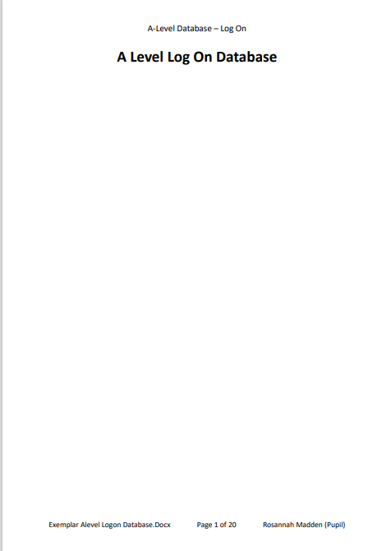
Appendix C: Year 12 Evidence of implementing a flatfile log on to a database and the subprograms to manage it. (Page 2 of 20)
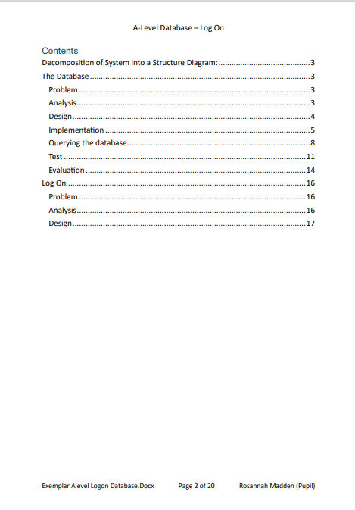
Appendix C: Year 12 Evidence of implementing a flatfile log on to a database and the subprograms to manage it. (Page 3 of 20)
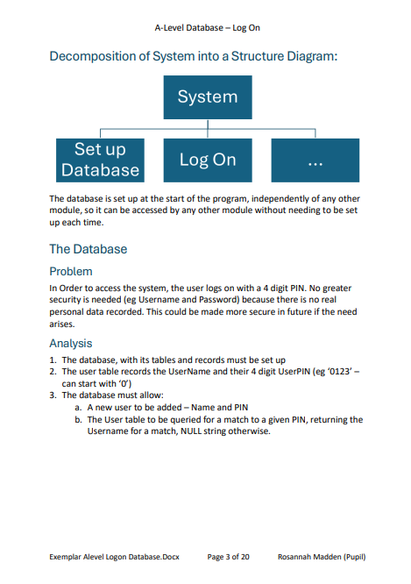
Appendix C: Year 12 Evidence of implementing a flatfile log on to a database and the subprograms to manage it. (Page 4 of 20)
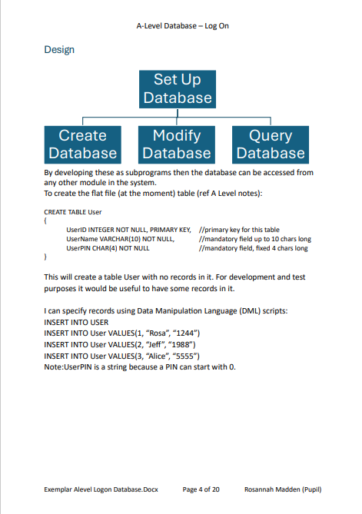
Appendix C: Year 12 Evidence of implementing a flatfile log on to a database and the subprograms to manage it. (Page 5 of 20)
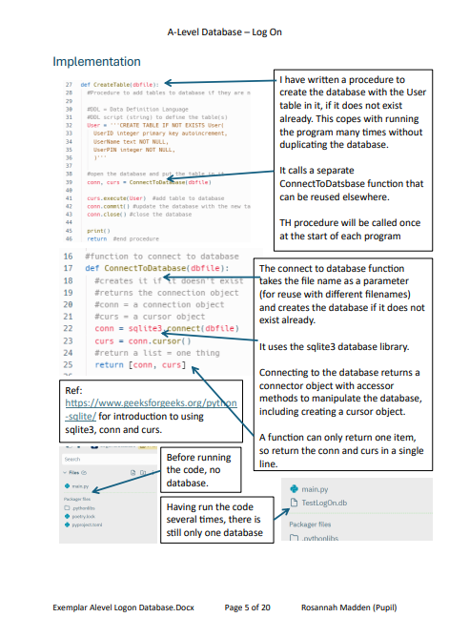
Appendix C: Year 12 Evidence of implementing a flatfile log on to a database and the subprograms to manage it. (Page 6 of 20)
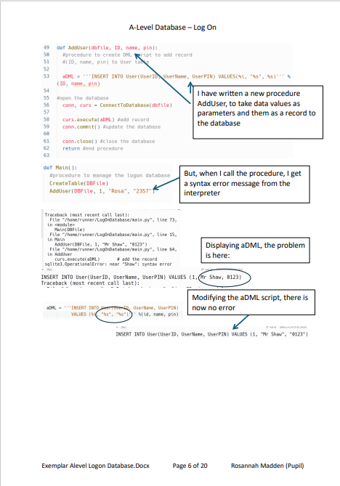
Appendix C: Year 12 Evidence of implementing a flatfile log on to a database and the subprograms to manage it. (Page 7 of 20)
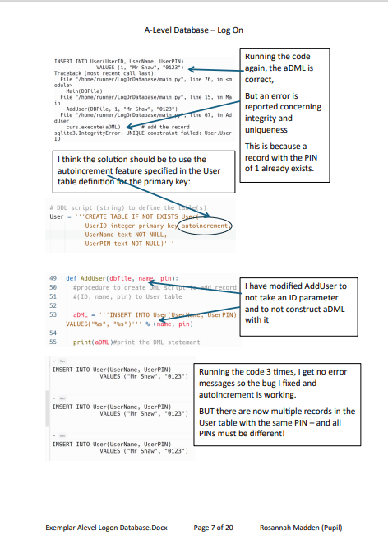
Appendix C: Year 12 Evidence of implementing a flatfile log on to a database and the subprograms to manage it. (Page 8 of 20)
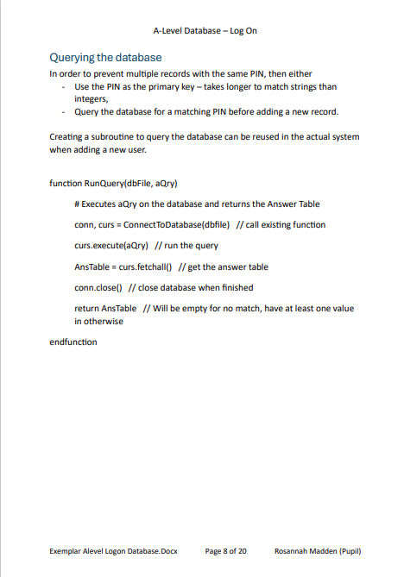
Appendix C: Year 12 Evidence of implementing a flatfile log on to a database and the subprograms to manage it. (Page 9 of 20)
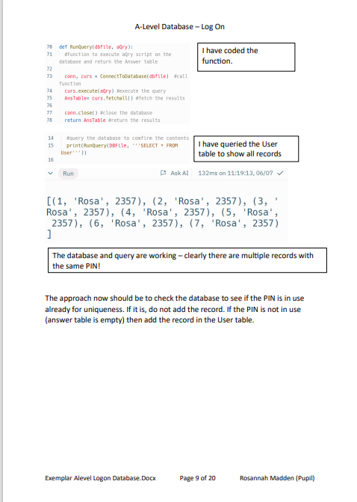
Appendix C: Year 12 Evidence of implementing a flatfile log on to a database and the subprograms to manage it. (Page 10 of 20)
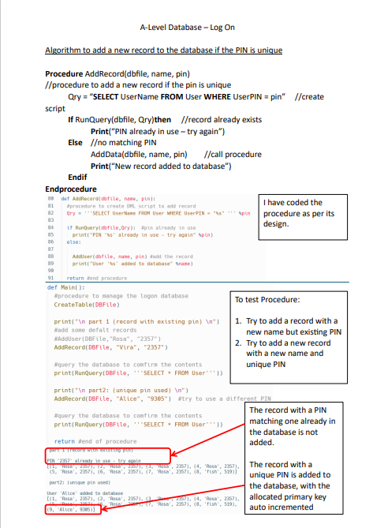
Appendix C: Year 12 Evidence of implementing a flatfile log on to a database and the subprograms to manage it. (Page 11 of 20)
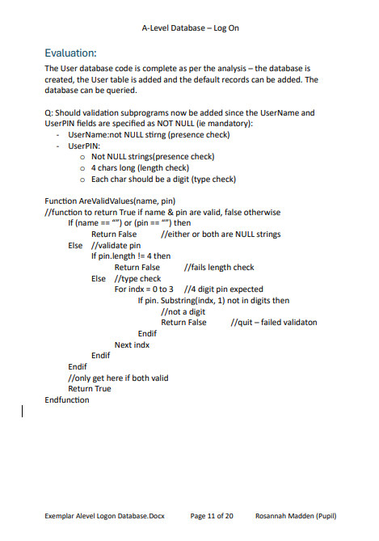
Appendix C: Year 12 Evidence of implementing a flatfile log on to a database and the subprograms to manage it. (Page 12 of 20)
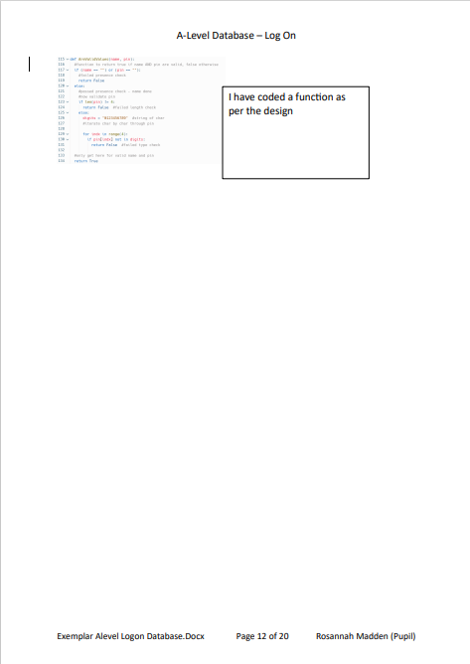
Appendix C: Year 12 Evidence of implementing a flatfile log on to a database and the subprograms to manage it. (Page 13 of 20)
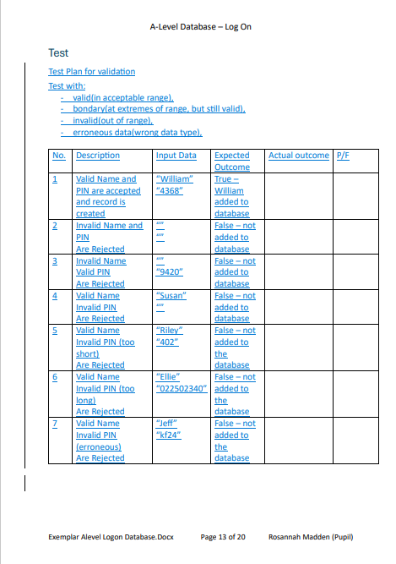
Appendix C: Year 12 Evidence of implementing a flatfile log on to a database and the subprograms to manage it. (Page 14 of 20)
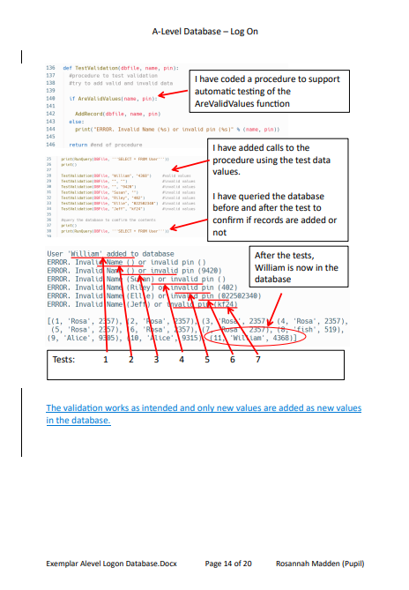
Appendix C: Year 12 Evidence of implementing a flatfile log on to a database and the subprograms to manage it. (Page 15 of 20)
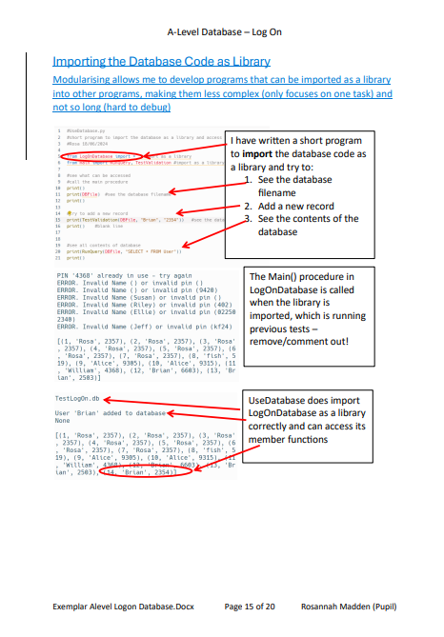
Appendix C: Year 12 Evidence of implementing a flatfile log on to a database and the subprograms to manage it. (Page 16 of 20)
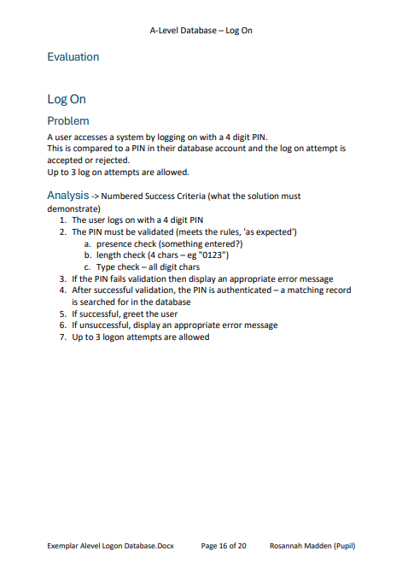
Appendix C: Year 12 Evidence of implementing a flatfile log on to a database and the subprograms to manage it. (Page 17 of 20)
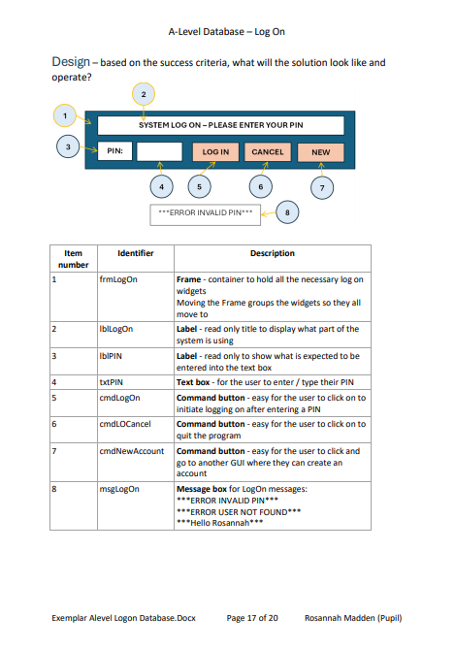
Appendix C: Year 12 Evidence of implementing a flatfile log on to a database and the subprograms to manage it. (Page 18 of 20)
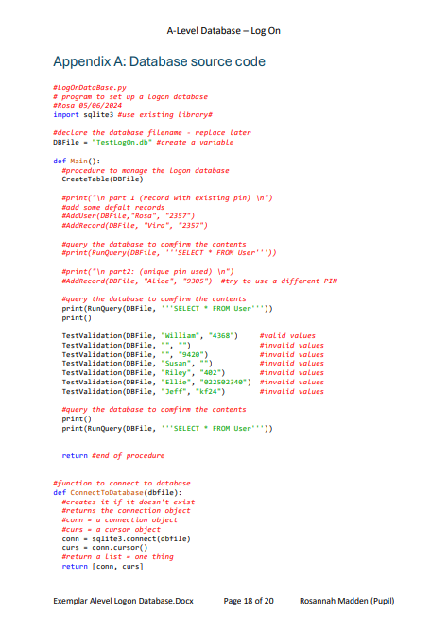
Appendix C: Year 12 Evidence of implementing a flatfile log on to a database and the subprograms to manage it. (Page 19 of 20)
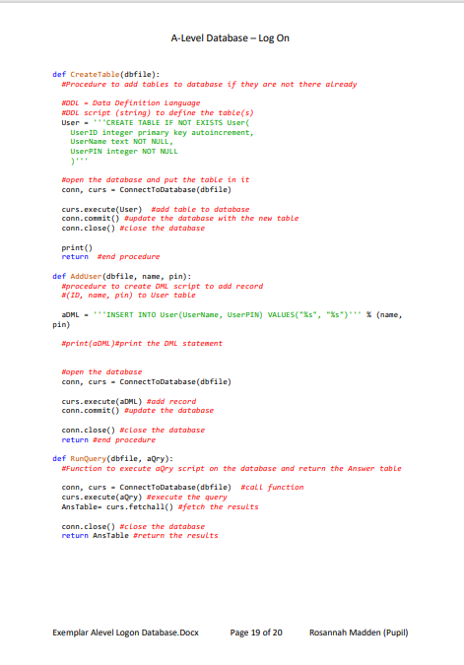
Appendix C: Year 12 Evidence of implementing a flatfile log on to a database and the subprograms to manage it. (Page 20 of 20)
